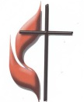
FIRST UNITED METHODIST CHURCH
NON-PROFIT ORG.
U.S. POSTAGE
PAID
KITTANNING PA 16201
PERMIT NO 14
301 NORTH JEFFERSON STREET
KITTANNING PA 16201
CHURCH OFFICE: 724-548-4312

ADDRESS SERVICE REQUESTED

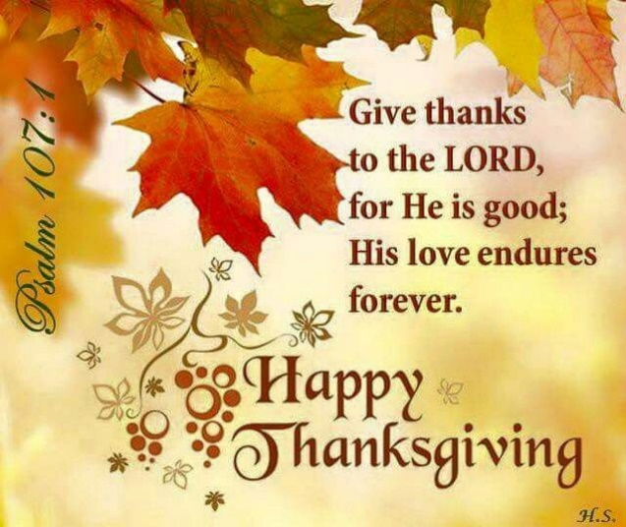
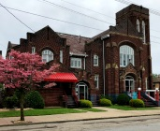
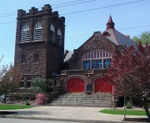
ARC LINK NEWSLETTER
NOVEMBER 2022

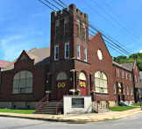
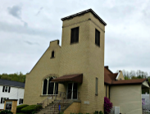

ALLEGHENY RIVER CHARGE
Senior Pastor:
Rev. Deb Kociban Pastor: Terri Wells

First United Methodist Church-301 N Jefferson Street, Kittanning PA 16201 724-548-4312
Worship 11:00 AM Sunday School 9:30 AM Email: fumchurchkittanning@comcast.net
Office Hours: Monday-Thursday 8:00 – 12:00 PM Website: firstchurchkittanning.com
Fax: 724-548-5157 Rainbow Road: 724-543-7569
Parsonage- 307 N Jefferson Street, Kittanning PA 16201 724-543-4808

Ford Memorial United Methodist Church-1024 Fourth Ave, Ford City PA 16226 724-763-1540
Worship 11:00 AM Email: fordmemc@comcast.net

Manorville United Methodist Church-P.O. Box 174, 800 Water Street, Manorville PA 16238
Worship 9:45 AM
Email: mumc@windstream.net 724-763-1254

Union Avenue United Methodist Church-421 Union Ave, Kittanning PA 16201
724-543-5012 Worship 9:00 AM

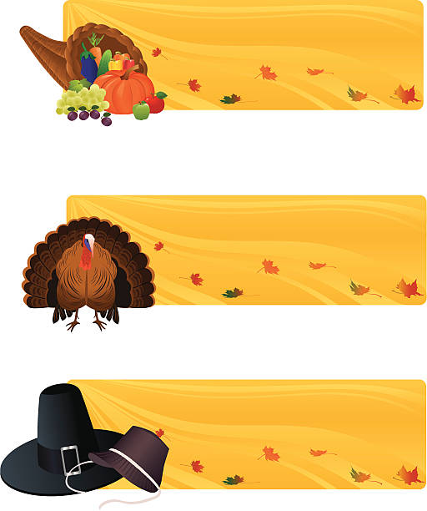






DECEMBER 2022 NEWSLETTER DEADLINE
Please get articles to Audrey no later than
SUNDAY, November 13, 2022. Thank you


Your word is a lamp before my feet and a light for my journey.
Pastor Deb’s
Message
Psalm 119: 105
Dear Brothers and Sisters in Christ,
I found in my email inbox today a great recipe for Loaded Potato and Buffalo Chicken casserole. From the looks of it, it will be perfect for a snowy, winter night. One of my favorite comfort food recipes is found in the Olmsted Manor cookbook from years ago. It is Shepherd’s Pie, but I make it with chicken instead of beef. Over the years I have printed out recipes for salads, for shrimp dishes, that can’t get rid of vegetable zucchini, and a host of others. My kitchen shelves hold a wide variety of cookbooks. There is one totally dedicated to chocolate desserts (are you surprised?) And yes, there is one Weight Watchers Slow Cooker cookbook. Browsing through recipes and cookbooks is something I enjoy doing.
Psalm 119 is the longest chapter in the Bible. It is written as an acrostic poem. There are 22 stanzas of the Psalm, each one corresponding to one of the 22 letters of the Hebrew alphabet. Each stanza has 8 verses for a total of 176 verses. Amazingly enough almost every verse speaks of God’s word in some way.
The author of the Psalm is unknown. Some have suggested it is Ezra the priest or David or even Daniel. Whoever it is, they have experienced many hardships in life and even persecution because they hold fast to the Word of God. The Psalm encourages every generation to stay close and focused on God’s Word no matter what is happening in the world or in our own personal lives. It proclaims that acknowledging God’s ways and obeying God’s law above all else is the only way to live wise, strong lives.
So, truth be told, I made the Shepherd’s Pie only once and I produced one of the recipes in the Weight Watchers cookbook. All the other recipes go untried and that’s a shame. The recipes are a wonderful resource for great meals, but if I don’t buy the ingredients, if I don’t get out bowls, pots and pans, if I don’t turn on the oven, the recipes are useless. I will never know the tasteful possibilities of any of them if I don’t actually use them.
It's the same way with the Word of God, if we don’t read it, it we don’t meditate on it, if we don't pray through it, we will never know the wonderful possibilities it holds to enrich our relationship with God and Jesus through the Holy Spirit. God’s Word is truly food for our souls and lamps for our path. Joyfully and thankfully read it and use it.
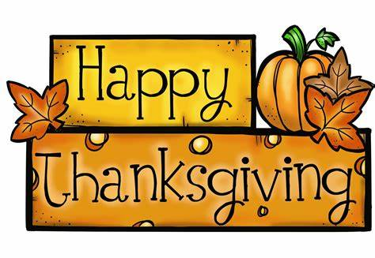
Blessings,
Pastor Deb

November has been nationally recognized for 47 different reasons. Some of those reasons are, Adopt A Senior Pet Month, Banana Pudding Lovers Month, Diabetic Eye Disease Month, Epilepsy Awareness Month, National Adoption Month, National Alzheimer’s Disease Month, National Fun with Fondue Month, National Peanut Butter Lovers Month, just to name a few of them. But, for Christians, Sunday, November 27 is the first day of Advent. November is the month we begin the period of preparation for the celebration of the birth of Jesus Christ at Christmas and for the preparation for the Second Coming of Christ. Chinese Christians light up their homes with colorful paper lanterns during Advent, and you might find red paper pagodas cut out and placed in windows. Families across Germany will set up an Advent wreath with four candles, one for each week of Advent. They may gather around the wreath each Sunday to sing carols and light another candle and Advent hosts may serve cookies that are spread around their wreaths. Advent in Mexico brings the religious ceremonies known as Las Posadas (Spanish for "The Inns.") This nine-day celebration that marks the journey of Mary and Joseph is held from December 16 to 24. Each evening in cities and villages across Mexico, a child dressed as an angel leads a processional, usually made up of children. They go to selected homes, where they are denied entry but often given refreshments. Poland, Advent brings prayer, fasting and spiritual preparation for Christmas. People stay inside during the long, dark evenings making decorations for the Christmas tree and handmade gifts, baking Christmas cookies, and preparing other delicacies for the upcoming holidays. People also set up outdoor booths in villages and city squares, decorated in themes of Christmas, where they will pass out candy, little gifts and cards. The United Kingdom, will have services with handmade Christingles. You make Christingles from an orange, which you decorate with a candle, red tape and sweets. The Christingles service might involve prayers, readings and singing. The world has developed many ways to mark this time in our lives as a special time, set apart from your normal, everyday life. Whatever you and your family choose to do, set aside time for family Bible study, attend an Advent bible study, give of your time (or baked goods!) to others, listen to popular Advent songs, or Light candles and pray. Whatever you choose to do, choose something, take the time to reflect that just as Jesus Christ came to earth for the salvation of our lives, he will come again. Let us be prepared!
Pastor Terri’s
Message

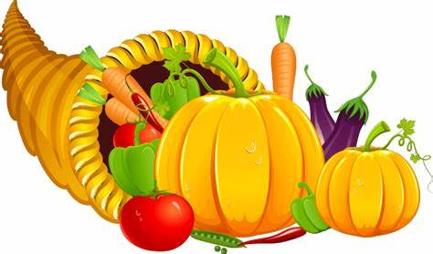

NOVEMBER LECTIONARY READINGS
November 20, 2022,
Christ The King Sunday
Jeremiah 23:1-6, Luke 1:68-69,
Colossians 1:11-20, Luke 23:33-43

November 27, 2022
1st Sunday of Advent
Isaiah 2:1-5, Psalm 122,
Romans 13:11-14, Matthew 24:36-44

November 6, 2022
22nd Sunday after Pentecost
All Saints Sunday
Haggai 1:15b-2:9, Psalm 145:1-5, 17-21,
2 Thessalonians 2:1-5, 13-17, Luke 20:27-38

November 13, 2022
23rde Sunday after Pentecost
Isaiah 65:17-25, Psalm 118,
2 Thessalonians 3:6-13, Luke 21:5-19

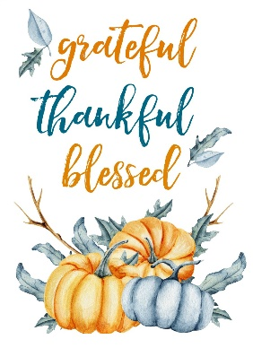


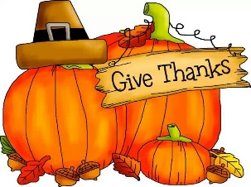
RAMPS OF HOPE DONATIONS
We are truly pleased to tell you of 2 donations that have recently been received by our ministry, Ramps of Hope. The Armstrong County team was blessed by Dayton UMC with a donation of $1,686.22 from their ramps ministry. For several years, they had a team that also built ramps in Armstrong but lately the church has been unable to have a team. Therefore, they have gifted us with money left in their funding for ramps. While we would indeed like to have their team still working in our county, we are very grateful for this wonderful donation. In addition, we received a donation of $2,000 from Grace Presbyterian Church in Kittanning. In deciding what charities to support from their rummage sale proceeds, they thought of us and sent us this generous donation with well wishes and gratefulness for our ramps ministry. We are indeed grateful to them as well for their generosity to Ramps of Hope.
We feel so blessed by these donations from our brothers and sisters in Christ from other churches. We know that they were led by God to do this for Ramps of Hope, and we feel that this is one example of reflecting Jesus to our community. This money will enable us to provide several ramps for Armstrong County residents, thus continuing to reflect Jesus through the work we do. We are grateful to these churches for their generous support of Ramps of Hope.
In Christ, Lynn and Tim



FIRST CHURCH LINK PAGES

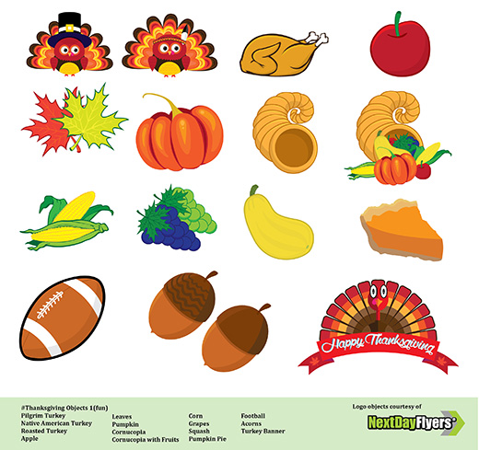
SOUND SCRIPTURE BELL WELCOME
SYSTEM READERS RINGERS CENTER
6 Gabe Smith 6 Brad Hellein 6 Madelyn Smith 6 Sarah Heckert
13 Tim Scaife 13 Carolyn Hancock 13 Chris Hankey 13 Melissa Bureau
20 Dave Yanoschick 20 Larry McKelvey 20 Logan Green 20 Karen Scaife
27 John Yankasky 27 Sarah Heckert 27 Wyatt Green 27 Beverly Patton
COUNTERS USHERS ACOLYTES
6 McKelvey 6 Asbury/Mary Jo Lipski 6 Madelyn Smith & Hallie Hoffman
13 Scaife 13 Epworth/Melissa Bureau 13 Ashley Yankasky & Carlee Beers
20 Ferguson 20 Epworth/Melissa Bureau 20 Evva Yanoschick & Chelsea Beers
27 Ternent 27 Oxford/Mark Ferguson 27 Joey Kachur & Logan Green

FIRST CHURCH LINK PAGES

NOVEMBER MISSIONS
We have an opportunity to help share in Missions for November. We will collect money for “Embrace Grace” an established mission program at the Free Methodist Church in West Kittanning. “Embrace Grace” is for single, pregnant, young women. These women receive love and support during a difficult yet joyful time of life. The women make friends and form bonds with other expectant moms while journeying through their pregnancy. The group meets weekly and a free baby shower will be given in young mothers honor. Our church will collect monies to contribute to this event. May God bless our efforts.
MARK YOUR CALENDAR
Mark your calendars for the September 2023 Rise Against Hunger packaging event. The date has been set for Saturday, September 9, 2023 at our church’s Covenant Center. 7:30 AM will be for set-up and 9:00 AM for packaging. Mark your calendars, church family.
NOVEMBER SIFT LUNCHEON
Date: Thursday, November 17, 2022
Time: Noon
Menu: “Thanksgiving Dinner” Turkey with stuffing, mashed potatoes and gravy, cranberries, corn, rolls, butter and cake for dessert
Program: Ramps of Hope. Providing semi-permanent ramps for people who need assistance exiting and entering their homes.
Reservations due by noon, Monday, November 14, 2022

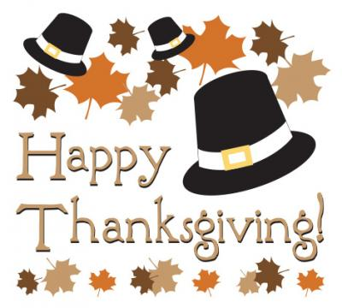


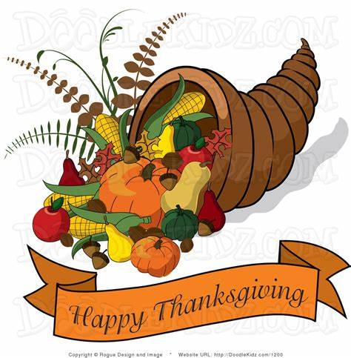


DECORATE THE CHURCH
We will be decorating the church for the Christmas Season on Tuesday, November 22nd beginning at 9:00 AM. Everyone is invited to come help. We are usually finished before noon.



2023 VBS ALUMINUM CANS
FOR HABITAT FOR HUMANITY
Our aluminum can collection for Habitat for Humanity for VBS 2023 continues.
Cans Received September 15th-October 15th 3,238cans
Total cans received through October 15th 14,572 cans
Many thanks to everyone who is saving aluminum cans and bringing them to the
church-at the ramp at the back of the church. If you haven’t been saving aluminum
cans, please start-soft drinks, juice, power drinks, tea, beer, cat food-Aluminum only-NOT “TIN CANS”, food, soup, etc. Thank you, The Can Man, Jim Ternent

FIRST CHURCH LINK PAGES

NOVEMBER BIRTHDAYS
1 Tim King 18 Sarah Heckert
4 Logan Green 19 Diane Weibel
4 Cindy Volek 20 Tony Krozely
6 Karen Scaife 20 Anita Smith
9 Christopher Hankey 20 Greg Toth
11 Katie Smith 21 Peyton Zielinski
13 Rachel Snow 22 Mert Hellein
14 Killian Vandevort 29 Kelly Hoffman

NOVEMBER ANNIVERSARIES
13 Pastor Deb & George Kociban-40 years
15 Harry & Michelle Waldenville-25 years
26 Roy & Bobbi Williamson -62 years



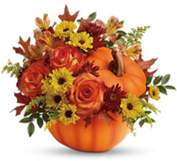


We extend our Christian compassion and concern to Patty (Rick) Swartz on the death of her mother, Margaret “Peggy” Reigard. Peggy passed away on Monday, October 10, 2022.

THANK YOU
Dear First United Methodist Church,
Thank you so very much for your continuous and very generous donation to our Blessings in a Backpack program! The canned pasta is a favorite and much appreciated. Thank you for the monetary donation-it will go far to help!
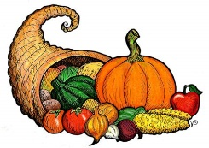
We started Blessings in a Backpack at West Hills Intermediate School in January 2016 with 15 students with a bag of food every Friday. Because of the unwavering and steadfast support of individuals, churches, school and community organizations, we are currently serving 238 students in both West Hills Primary & Intermediate Schools, Lenape Elementary, Elderton Elementary, Dayton Elementary and Shannock Valley Elementary schools. Because of you the elementary students in the Armstrong School District will have hunger free weekends. Thank You, Molly Atwood



FORD MEMORIAL LINK

NOVEMBER BIRTHDAYS

NOVEMBER
ANNIVERSARY

MANORVILLE LINK PAGE

IN LOVING MEMORY OF:
Jim Orton on his birthday 11/23
Bonnie Hynick

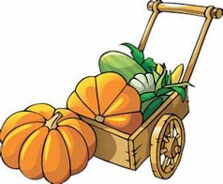
FINANCIAL COUNTERS
6 - JB & Jack
13 - Mike & Lu
20 - Nancy & Nancy
27 - Steve & Lu

ALL SAINTS’ SUNDAY AT MANORVILLE
Orders are due BY Oct. 30th to Luella for your tea lights for November 6th. We will be celebrating All Saints' Sunday with recognition of our loved ones.

We only lost one saint this year for whom we will have a place setting at the Saints' Table - Betty Fox, who was a beloved member of our church for many years, just passed away on Oct. 15th. Betty had experienced health problems the last few years and resided with her daughter, Dianna and husband, Bob, and granddaughter, Maria. Our sympathy goes out to all who loved her and will miss her.

CHRIST THE KING SUNDAY

November 20th is Christ the King Sunday. Everyone is encouraged to take in a favorite cross and help to decorate the sanctuary.

DECORATE THE SANCTUARY
November 20th we will be decorating the sanctuary for Advent/Christmas following worship. During Advent/Christmas there will be various nativity sets on the sanctuary windowsills to view and enjoy. Upon completion of the decorating we will enjoy a pizza lunch.

ADVENT COIN FOLDERS
Advent coin folders will be available for those who wish to observe an Advent discipline of dropping a quarter a day in the slot, totaling $10. Not really that much but it all adds up. This will go towards a mission project.

THANK YOU
The Ford City Food Bank wishes to thank Manorville for their faithful support of their ministry. Every month people come in with hopeful hearts that they will be able to receive enough food to feed themselves till the next time. Most of our clients are elderly and on a fixed income and truly appreciate a hand up that we can give them. Thank you for your generous hearts.
NOVEMBER BIRTHDAYS
1 Cameron Lewis Welch
4 Randy Reesman
6 Joshua Walker
11 Heather Arblaster
20 Xenia Zielinski
28 Nicole Zielinski
30 Carol (Reesman) Snyder
30 Natalie Tohy
NOVEMBER ANNIVERSARY
26 Mike & Paige Querry

UNION AVENUE LINK PAGE

The October 3, 2022 meeting of the Union Ave. United Women in Faith was held in the Kittanning Cottages Community room with 10 in attendance. The meeting opened with the reading of “The Purpose of the UWF, led by President Karen Wolfe.
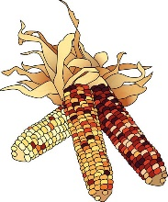
Hostess: Donna Titus
Devotions: Karen Wolfe Acts 26:16 His Servant and His Witness
Minute Missions: Carolyn Ingram, Spirit of Service
Prayer Calendar: Peggy Say’ sent birthday cards to missionaries
The secretary’s and treasurer’s reports were read and accepted.

United Women in Faith: Do we want to remain members? There are no specific requirements to be members. Motion made to remain members and to pay our pledge for 2023. All were in agreement. Instead of Prayer and Self Denial and Thank Banks, we will have a Mission Day and take up a collection for this. Motion made to pledge same amount in 2023 as in 2022. Motion carried.

World Gospel Mission: Wants general donations instead of a donation for an individual missionary as previously. A motion was made to not give a donation for this. Motion was seconded and motion passed.

Peggy received money from hoagie coupons except for 3 books. If anyone wants a book, please see Peggy.
Service pin will be awarded at our Christmas Party.
We will collecting items for the Ruth M. Smith Home until November 6th. Sandy & Lynn will deliver on November 8, 2022.
A motion was made to give a donation of $150 to the House of the Carpenter. Motion passed.
The United Methodist Men are having a Pancake and Sausage dinner on October 25, 2022. There will be 2 times. 11AM-1PM and 4PM to 7PM. They would like to have baked goods for a bake sale. Please see Donna Shaffer if you can donate baked goods. Proceeds will go to support Ukraine.
Christmas luncheon will be at the Craft House on December 5, 2022 at 1PM.
Meeting closed with the reading of the UWF prayer.
Secretary, Ellen Nelson

NOVEMBER
BIRTHDAYS
2 Lori Goepfert
8 Donna Titus
9 Gary Anderson
24 Vaila Clever
24 Vieira Clever

NOVEMBER
ANNIVERSARY
13 George & Pastor Deb Kociban-40 years

