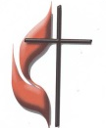
FIRST UNITED METHODIST CHURCH
NON-PROFIT ORG.
U.S. POSTAGE
PAID
KITTANNING PA 16201
PERMIT NO 14
301 NORTH JEFFERSON STREET
KITTANNING PA 16201
CHURCH OFFICE: 724-548-4312

ADDRESS SERVICE REQUESTED


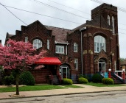
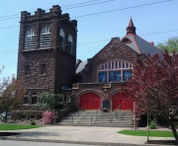
ARC LINK NEWSLETTER
OCTOBER 2022

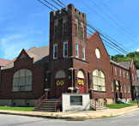
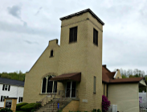

ALLEGHENY RIVER CHARGE
Senior Pastor: Rev. Deb Kociban Pastor: Terri Wells

First United Methodist Church-301 N Jefferson Street, Kittanning PA 16201 724-548-4312
Worship 11:00 AM Sunday School 9:30 AM Email: fumchurchkittanning@comcast.net
Office Hours: Monday-Thursday 8:00 – 12:00 PM Website: firstchurchkittanning.com
Fax: 724-548-5157 Rainbow Road: 724-543-7569
Parsonage- 307 N Jefferson Street, Kittanning PA 16201 724-543-4808

Ford Memorial United Methodist Church-1024 Fourth Ave, Ford City PA 16226 724-763-1540
Worship 11:00 AM Email: fordmemc@comcast.net

Manorville United Methodist Church-P.O. Box 174, 800 Water Street, Manorville PA 16238
Worship 9:45 AM
Email: mumc@windstream.net 724-763-1254

Union Avenue United Methodist Church-421 Union Ave, Kittanning PA 16201
724-543-5012 Worship 9:00 AM







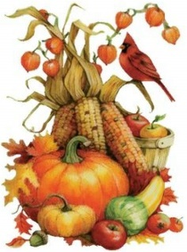
NOVEMBER 2022 NEWSLETTER DEADLINE
Please get articles to Audrey no later than
SUNDAY, October 16, 2022. Thank you


Where there is no vision, the people perish.
Proverbs 19: 18a
Pastor Deb’s
Message

Dear Brothers and Sisters in Christ,
“Let’s paint the bathroom! It needs some color,” she said. The beige that was inherited from the previous renters was dull and tiresome. “Great idea,” he said, “What color?” “How about yellow?” came the answer. And so it was, the bathroom became yellow. “Hon, I’m not really liking the yellow,” she said. “Oh, okay. What color would you like?” he asked reluctantly. “How about green?” And so it was, the bathroom became green. He caught her eyeing the bathroom walls and tried to avoid her. Too late. “Babe, the green’s not working either,” she sighed. You’ve got to be kidding me, he’s thinking while smiling at her. “What color this time?” he says holding his tongue. “Peach, definitely, peach.” And so it was, the bathroom became peach until the day they moved out, 3 years later.
King Solomon, the wisest man to have ever lived, is the author of Proverbs. Throughout the collection of sayings, wisdom is found in the revealed will of God for the nation and for individuals. The collection was written so that the readers would learn the fear of the Lord and to receive teaching in righteous living through justice.
This verse contains a warning. When the people of God do not pay attention to the vision that God has for them, they have no future. When the people of God do not earnestly seek out God’s direction for their lives, they will die. When the people of God ignore God’s will for them, they will produce no lasting legacy of faith.
It is more imperative than ever that we as the people of God discover again God’s vision for our churches. As we all seek to bring the kingdom of God to our neighborhoods, we need to earnestly pray for God to reveal God’s vision and plan for our churches. If we do not have that vision, we will spin our wheels and we will be unable to impact our local world for God.
The last time George and I painted a bathroom, we painted it white. It was white when we bought the house. It was white the 20 years we lived there. It was white when we sold it. Clearly, I do not have an interior decorator’s vision for our home. Without vision, our bathroom remained white and uninteresting.
Thankfully for the church, God has a vision and plan that will lead us into a future that stamps the kingdom of God on the hearts of our neighbors and friends. God's vision for our churches will change lives. The wisdom of Solomon is true today. Where there is no vision, the people perish. Not only will the people of God perish, but the people who will not know God’s love through us will also perish.
Let us diligently seek after God’s vision for our churches so that all may live.

Blessings,
Pastor Deb

OCTOBER LECTIONARY READINGS
October 16, 2022,
19th Sunday after Pentecost
Laity Sunday
Jeremiah 31:27-34, Psalm 119:97-104,
2 Timothy 3:14-4:5, Luke 18:1-8

October 23, 2022
20th Sunday after Pentecost
Joel 2:23-32, Psalm 65,
2 Timothy 4:6-8, 16-18, Luke 19:1-10

October 2, 2022
17th Sunday after Pentecost
World Communion Sunday
Lamentations 1:1-6, Psalm 137,
2 Timothy 1:1-14, Luke 17:5-10

October 9, 2022
18th Sunday after Pentecost
Jeremiah 29:1, 4-7, Psalm 66:1-12,
2 Timothy 2:8-15, Luke 17:11-19



October 30, 2022
21st Sunday after Pentecost
Reformation Sunday
Habakkuk 1:1-4; 2:1-4, Psalm 119:137-144,
2 Thessalonians 1:1-4, 11-12, Luke 19:1-10


UNITED METHODIST MEN GROUP FUNDRAISER
The United Methodist Men Group will have a pancake and sausage fundraiser, proceeds going to people of Ukraine. Date will be Tuesday, October 25th at Ford Memorial UM Church. All proceeds will be given to UMCOR for distribution. There will be 2 sittings 11:00-1:00PM and 4:00-7:00 PM. All men of the charge are invited to participate.


Allegheny River Charge Celebrates Our Pastors
Clergy Appreciation 2022
October is Pastor Appreciation Month, and the Staff Parish Committee asks that you show your love and appreciation to both Pastor Deb and Pastor Terri.
The Allegheny River Charge churches are indeed blessed by the presence of both of our pastors. Pastor Deb and Pastor Terri are working tirelessly during these unsettling times, finding new ways to care for us and finding ways to assure that the word of God continues to be shared.
Please set aside some time, especially this month, to express your gratitude and love to each of our spiritual leaders. Perhaps you can send a personal note or better yet, express your thanks in person and as always, we ask that you remember each in your daily prayers.
Be sure to let Pastor Deb and Pastor Terri know that you appreciate their never-ending labor in the name of God.

“How beautiful are the feet of them that preach the Gospel of Peace
and bring glad tidings of good things.”
~ Romans 10:15

FIRST CHURCH LINK PAGES


SOUND SCRIPTURE BELL WELCOME
SYSTEM READERS RINGERS CENTER

2 Gabe Smith 2 Chelsea Beers 2 Sarah Heckert
9 Tim Scaife 9 Caden King 9 Melissa Bureau
16 Dave Yanoschick 16 Jocelyn King 16 Karen Scaife
23 John Yankasky 23 Ashley Yankasky 23 Beverly Patton
30 Tim King 30 Evva Yanoschick 30 Mary Jo Lipski

COUNTERS USHERS ACOLYTES
2 Scaife 2 Oxford/Mark Ferguson 2 Ryan Bish
9 Ferguson 9 Oxford/Mark Ferguson 9 Madelyn Smith & Hallie Hoffman
16 Ternent 16 Albright/Dan Wolfe 16 Ashley Yankasky & Carlee Beers
23 Yankasky 23 Albright/Dan Wolfe 23 Evva Yanoschick & Chelsea Beers

30 Bureau 30 Asbury/Mary Jo Lipski 30 Joey Kachur & Logan Green

OCTOBER MISSIONS
UNDIES for the HOUSE OF THE CARPENTER. We continue yearly to donate money for people who go to “the Underwear Room”. Our monies will provide brand new underwear for men, women, teens & children. Do you know that these “unmentionables” are the most under-donated, yet most needed item of clothing for the needy? Providing new underwear improves the lives of people, helps their cleanliness & warmth, and brings an unspoken sense of dignity and well-being! Give generously…it will bring a smile to your heart and sunshine to your soul. Lynn & Sandy

OCTOBER SIFT LUNCHEON
Date: Thursday, October 20th
Time: Noon
Menu: Spaghetti with Homemade Meat Sauce, Tossed Salad, Italian Bread and Cookies for dessert
Program: “The Accordion Man” Dave Palezney
Reservations due by noon, Monday, October 17th


2023 VBS ALUMINUM CANS
FOR HABITAT FOR HUMANITY
Our aluminum can collection for Habitat for Humanity for VBS 2023 continues.
Cans Received August 15th-September 15th 5,541cans
Total cans received through September 15th 11,334cans
Many thanks to everyone who is saving aluminum cans and bringing them to the
church-at the ramp at the back of the church. If you haven’t been saving aluminum
cans, please start-soft drinks, juice, power drinks, tea, beer, cat food-Aluminum only-NOT “TIN CANS”, food, soup, etc. Thank you, The Can Man, Jim Ternent


FIRST CHURCH LINK PAGES
OCTOBER BIRTHDAYS
2 Brandon Schrecengost 15 Brad Volek
6 Sierra Aires 17 John Yankasky
6 Norm King 21 Rowan Vandevort
6 Patrick Wolfe 22 Lance Zielinski
7 Matthew Kachur 26 Ada Bowser
10 Frank Kiss 28 Ryan Cornman
11 Melissa Bureau 30 Hayley Hoffman
13 Connie Bish 31 Pam Shaffer
14 Harry Waldenville



OCTOBER ANNIVERSARIES
3 James & Diane Weibel
8 Ryan & Sally Cornman-11 years
12 Larry & Janet McKelvey-20 years
24 Matthew & Jolena VanMeter-8 years
30 Rob & Sue Hankey-41 years


THANK YOU
Thank you all for the monetary and stamp donations to continue the card ministry. Caring Friends

AREA CHURCHES PACK 25,000 MEALS FOR RISE AGAINST HUNGER
On Saturday September 10, members of five churches gathered at Leechburg First United Methodist Church to pack 25,000 nutritious meals for Rise Against Hunger. Volunteers ranged in age from six to ninety-eight, and along with Leechburg included members from First United Methodist Church in Vandergrift, New Beginnings United Methodist Church in Apollo, Pine Run Community Church, and First United Methodist Church in Kittanning. Boy Scout troops #670 and #6670 from Ford City provided support for the event. Central Presbyterian Church of Tarentum also contributed financially to the meal purchases.
Rise Against Hunger was founded in 1998 and has twenty-eight locations across the U.S. and six international. They have provided over 539 million meals for the hungry in the United States and 78 countries. Through the meal packaging and other efforts, their aim is to end world hunger by 2030. More information can be found at https://www.riseagainsthunger.org.
FORD MEMORIAL LINK
OCTOBER BIRTHDAYS
1 Brenda Berrett
6 Caleb Berrett
11 Lowell Simmons
27 Brodie Lemmon
30 Clara Beckett


OCTOBER
ANNIVERSARY
23 Amanda & Dave Dingey

UNITED METHODIST WOMEN
The United Methodist Women organization has changed its name to united Women in Faith Our next meeting at Ford Memorial Church will be October 17th at 1:00 PM. All women are cordially invited to attend. We currently are planning a Hoagie Sale for delivery on October 20th. Orders cost $8 per hoagie and can be phoned in to Betty Clarke 724-388-2416 by Saturday, October 8th.
MANORVILLE LINK PAGE
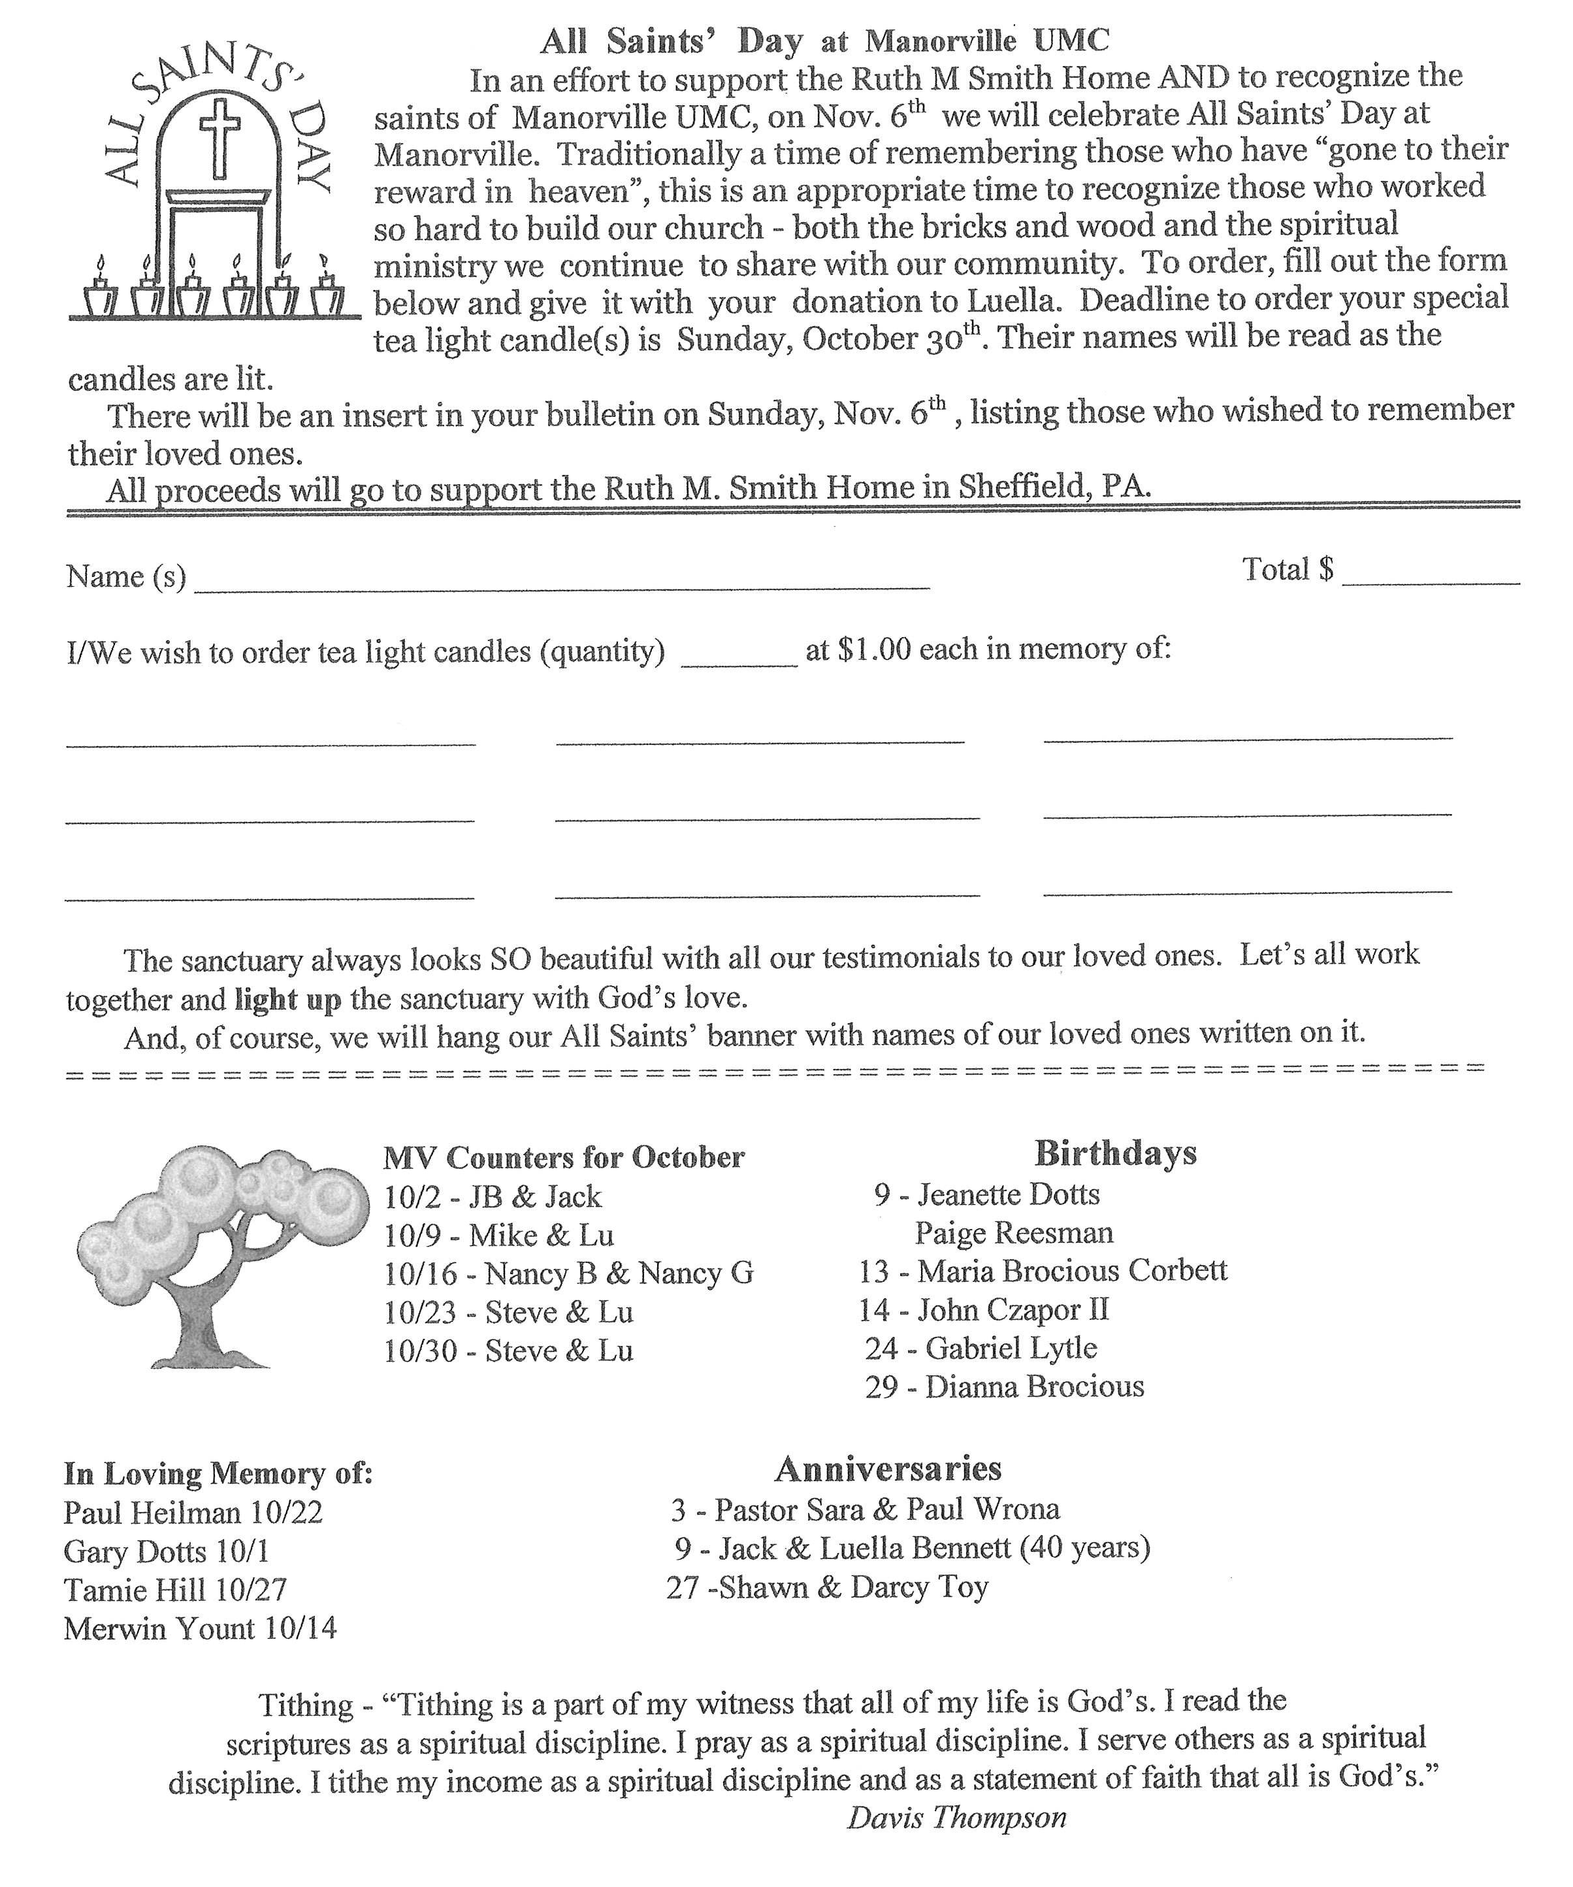


UNION AVENUE LINK PAGE

The September 12, 2022 meeting of the Union Ave. UMW was held at the Kittanning Cottages Community Room with 12 in attendance. The meeting opened with the reading of “The Purpose of the UMW,” led by President Karen Wolfe.
Hostess: Ellen Nelson
Devotions: Lynn Sibley-Ecclesiastes 3: 1-10
Minute Missions: Donna Shaffer, Ubunto Day of Service @ assembly 2022
Prayer Calendar: Donna Titus, Wesley house Family Service

The Secretary’s and Treasurer’s reports were read and approved.
Thank You received from East Brook Missions.
Requests for donations received from World Gospel Missions, Salvation Army, Family Focus, and Red Bird Missions.
Diaper Bags completed except for bottles. Carolyn will get bottles and diaper bags will be given to Pastor Terri on the last Sunday of September.
Do we want to sell hoagie coupons? Yes, Peggy will get 30 books of coupons.
Do we need to officially be in the UMW? We can do much more if we are working together as opposed to separately. Lynn & Sandy will talk with Linda Thayer to see what is required to be in the UMW. We will complete our pledge to UMW for 2022. Peggy is still trying to get a program book, Response Magazine, and service pin. All cards will now have to be sent electronically.
Questions asked concerning membership in UMW-
- Do we need to concentrate on trying to get a gem rating?
- Can we give our p ledge and other requirements with out buying a program book?
A vote was taken as to who will receive the service pin this year.
Will need to send 2 cards @ $5.00 each. Cards need to be ordered from the UMW.
Peggy and Lynn will get and send.
Ruth M. Smith home is in need of many items since floods in area. A motion was made, and
seconded and passed to collect items for the home. Donna Shaffer will put list of items needed in the bulletin.
Officers for 2023:
President: Karen Wolfe
Vice President: Donna Shaffer?
Secretary: Ellen Nelson
Treasurer: Peggy Say
Thank Banks and Blessing Bags will be Sunday, November 13, 2022.
Motions made and passed to give $100 to the Turkey Fund, $250 to support a family at Christmas through the community Action Agency, and $250 to Red Bird Mission.
A motion was made and passed to have our Christmas Lunch at a local restaurant. Peggy will inquire as to where and price.
Meeting ended with the UMW Prayer.
Secretary: Ellen Nelson
OCTOBER BIRTHDAYS
4 Claire Brown 21 Carolyn Ingram
20 Dave Wolfe 30 Peggy Say





