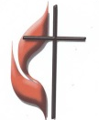
FIRST UNITED METHODIST CHURCH
NON-PROFIT ORG.
U.S. POSTAGE
PAID
KITTANNING PA 16201
PERMIT NO 14
301 NORTH JEFFERSON STREET
KITTANNING PA 16201
CHURCH OFFICE: 724-548-4312

ADDRESS SERVICE REQUESTED

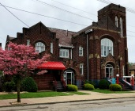
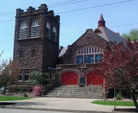
ARC LINK NEWSLETTER
AUGUST 2022



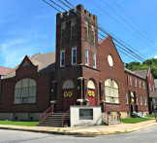
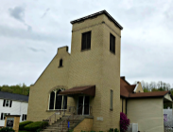

ALLEGHENY RIVER CHARGE
Senior Pastor: Rev. Deb Kociban Pastor: Terri Wells

First United Methodist Church-301 N Jefferson Street, Kittanning PA 16201 724-548-4312
Worship 11:00 AM Sunday School 9:30 AM Email: fumchurchkittanning@comcast.net
Office Hours: Monday-Thursday 8:00 – 12:00 PM Website: firstchurchkittanning.com
Fax: 724-548-5157 Rainbow Road: 724-543-7569
Parsonage- 307 N Jefferson Street, Kittanning PA 16201 724-543-4808

Ford Memorial United Methodist Church-1024 Fourth Ave, Ford City PA 16226 724-763-1540
Worship 11:00 AM Email: fordmemc@comcast.net

Manorville United Methodist Church-P.O. Box 174, 800 Water Street, Manorville PA 16238
Worship 9:45 AM
Email: mumc@windstream.net 724-763-1254

Union Avenue United Methodist Church-421 Union Ave, Kittanning PA 16201
724-543-5012 Worship 9:00 AM







SEPTEMBER 2022 NEWSLETTER DEADLINE
Please get articles to Audrey no later than
SUNDAY, August 14, 2022. Thank you


“I believe in God, the Father Almighty…And in Jesus Christ his only Son, our Lord…I believe in the Holy Spirit…” (taken from the Apostle’s Creed)
Pastor Deb’s
Message

Dear Brothers and Sisters in Christ,
It felt like I was living in another country. What does you’uns mean? It took a while for me to figure out it was the slang for the plural ‘you.’ Other conversations had me confused as to what kind of drink “pop” was or what in the world was a “buggy?” And for goodness sake who goes to the ‘beach?’ Where I hailed from, we drank soda, used a shopping cart, and we vacationed at the shore. Clearly, Toto, we were not in Kansas anymore!
What we know as the Apostles’ Creed likely originated from the Old Roman Creed which was in use as early as the second century. Its current form evolved over the centuries and was finally recognized by Charlemagne in the early ninth century. Even if we do not recite it often in worship, when we do the words come back to us from somewhere deep in the soul of our faith.
The creed states those beliefs about God, Jesus Christ, and the Holy Spirit that every Christian holds in common. Whether we live in the USA or Germany or Peru, all around the globe Christians believe what is stated in the Apostles’ Creed. Belief in God the Father, Christ his son and the Holy Spirit are the foundational truths of every Christian’s faith. We can differ on just about everything else, but these things are true for all of us.
John Wesley had great hopes for the people called “Methodists.” He hoped that Methodists would lead the way in living scriptural holiness. He hoped that Methodists would become a people of God, and not a hollow form of religion. Wesley believed this was possible because, “But as to all opinions which do not strike at the root of Christianity, we (Methodists) think and let think.”
It is popular in our culture today to lash out at those who express opinions different from our own. At times, that attitude has wormed its way into our church, and into our relationships with one another. We have set aside the roots of our faith and have allowed ourselves to be distracted from what matters most, our faith in God the Father Almighty, and in Jesus Christ, God’s only Son, and in the Holy Spirit.
No, I don’t live in Kansas. I live in Western Pennsylvania. I still don’t say you’uns. I drink soda and use a shopping cart, but when I can I love to sit on the beach! I love the way this end of the state embraces its neighbors and how we are all the same when we wear black and gold. It’s all a matter of remembering our roots.
As United Methodist Christians, we need to sink ourselves deeply into our roots of faith. The roots expressed in the Apostles’ Creed unite us as the people of God in those beliefs that matter the most. It is those roots that ground us in God and not in the world. It is those roots that save us through Jesus Christ. It is those roots that empower us to live faithfully in the Holy Spirit. And to everything else, “…we think and let think.”
Blessings, Pastor Deb
“Do not conform any longer to the pattern of this world, but be transformed by the renewing of your mind. Then you will be able to test and approve what God's will is--his good, pleasing and perfect will.” Romans 12:2
Pastor Terri’s
Message
The farmers always say corn should be “Knee high by the Fourth of July”. As I live in a very rural farm area, it is very safe to say that the corn is Knee High by the Fourth of July this year. I, for one, dislike the heat with a passion. I enjoy heat to the temperature of mid-seventies, after that, it is too hot for me. But, for the plants, they LOVE IT!!!!! I find that to be true in my life, there are parts of life that I do not like to have to live through. I do not like to have to learn more patience, I do not like to learn to sit back and not take control of my destiny, it is like enduring the hot, steaming weather of summer. It is uncomfortable, feels unbearable, and feels never ending. But I know in my heart, the more I learn to have faith and let go of the controls, the more I learn to utilize my patience, that I become stronger and grow a little more. When the summer weather hits in the 90’s, I am so very blest to have central air conditioning. When I get home and step into the coolness and breath the fresh, cool air into my lungs, it is like having an oxygen treatment. I am refreshed and renewed to handle the misery outside my door. That is what it is like to have God in my life. When I am tested, when I am going through a time where I am having to practice patience, understanding and feeling like I have no control over the things in my life, I turn to God. I listen to some Christian music, I spend time reflecting in the goodness he has provided me throughout my life and I go in prayer. I gather my spiritual, cleansing breath like breathing in the cool air of air conditioning. I find peace and serenity.
AUGUST LECTIONARY READINGS
August 21, 2022,
11th Sunday after Pentecost
Jeremiah 1:4-10, Psalm 71:1-6,
Hebrews 12:18-29, Luke 13:10-17

August 28, 2022
12th Sunday after Pentecost
Jeremiah 2:4-13, Psalm 81:1, 10-16,
Hebrews 113:1-8, 15-16, Luke 14:1, 7-14

August 7, 2022
9th Sunday after Pentecost
Isaiah 1:1,10-20, Psalm 50:1-8, 22-23
Hebrews 11:1-3, 8-16, Luke 12:32-40

August 14, 2022
10th Sunday after Pentecost
Isaiah 5:1-7, Psalm 80:1-2, 8-19,
Hebrews 11:29-12:2, Luke 12:49-56




MARK YOUR CALENDAR!!!
Our Annual Outdoor All Charge Worship Service and Picnic will be held Sunday, August 28
at Ingram park (460 Troy Hill Road, Kittanning). The Worship Service will begin at 11:00 AM
with special musical guests, Suzy and Bryon Chertik. A free will offering will be collected for
Suzy and Bryon in gratitude for the worship music that they will provide. (please give your regular weekly offering to your home church, the Sunday before or after the picnic.)
Food, Fun, and Fellowship will follow Worship. Please bring a salad, side dish or dessert to share. Main dishes and beverages will be provided. Watch your bulletin for more details.
See you on August 28!

ALL CHARGE PICNIC PLANNING MEETING
You are invited to join in the planning for our Charge Picnic. We will meet on Tuesday,
August 16 at 6:30 PM in the Covenant Center at First Church. Join us as we divide the many
responsibilities of the picnic between our churches. We hope to see YOU! Thanks,
Charge SPRC Members

FOLK FESTIVAL
The time has arrived for the Annual Fort Armstrong Folk Festival, August 4th-7th. As in past years, First Church will operate a food booth at the festival. My message for now is very simple:
WE NEED HELP!
HELP – Saturday, July 30, 9:00-12:00 – Come to Covenant Center to help to set up booth and prepare for festival.
HELP – During festival hours – work in booth – take orders, prepare orders, fry fish and fries. Call Melissa Bureau at 724-859-2607 to schedule a time.
HELP – Thursday, Friday, Saturday nights of festival from 9:00 - ? Clean up from the day’s activities and get ready to restart the next day. Show up at 9:00.
HELP - Sunday from 5:00 - ? -Clean up, tear apart and put away festival booth and materials. Show up at Covenant Center at 5:30 PM.
Activities committee, Tim Scaife Chairman 724-664-5346

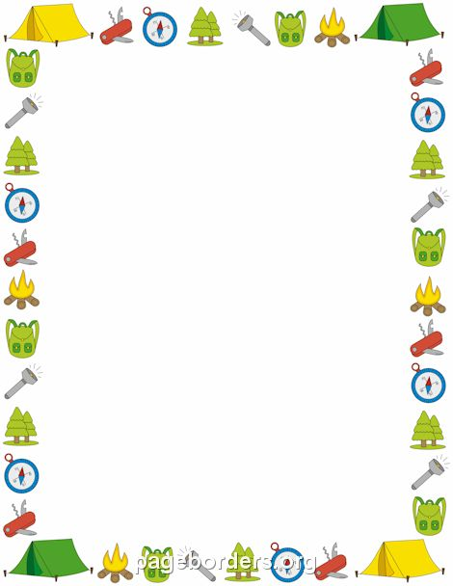
FIRST CHURCH LINK PAGES

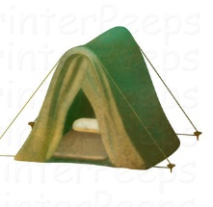
SOUND SYSTEM COUNTERS USHERS


7 Dave Yanoschick 7 Bureau 7 Oxford/Mark Ferguson
14 John Yankasky 14 McKelvey 14 Oxford/Mark Ferguson
21 Tim King 21 Scaife 21 Albright/Dan Wolfe
28 Gabe Smith 28 Ferguson 28 Albright/Dan Wolfe

BELL WELCOME ACOLYTES


RINGERS CENTER
7 Caden King 7 Sarah Heckert 7 Ashley Yankasky & Carlee Beers
14 Jocelyn King 14 Melissa Bureau 14 Evva Yanoschick & Chelsea Beers
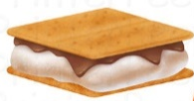
21 Ashley Yankasky 21 Karen Scaife 21 Joey Kachur
28 Evva Yanoschick 28 Beverly Patton 28 Ryan Bish
T-SHIRT SALES
New First Church T-Shirts are available to order. They have the new mission statement on the back and come in various sizes with your choice of either slate blue or cream colored shirts. Sweatshirts are also available if you would like one. Order blanks are in the office and sanctuary. Make checks payable to the church.

AUGUST BIRTHDAYS
4 Bonnie Bowser 29 Rob Hankey
13 Evva Yanoschick 30 Becky Zielinski
26 Brian Muir 31 Chelsea Beers
28 Macy Green 31 Derek Green



AUGUST ANNIVERSARY
1 Frank & Esther Kiss
8 Lance & Becky Zielinski-24 years
25 John & Kimberly Yankasky
26 Tony & Sally Krozely-61 years

FIRST CHURCH LINK PAGES
2022 VBS ALUMINUM CANS
FOR HABITAT FOR HUMANITY
We continue our aluminum can collection for Habitat for Humanity
Cans Received May 15th-June 15th—7,330
Total cans received through June15th—52,523
Many thanks to everyone who is saving aluminum cans and bringing them to the church-at the ramp at the back of the church Thank you, The Can Man,
Jim Ternent
Total cans received Bible School Week-6,349
Total cans for the ENTIRE VBS YEAR (June 15. 2021- June 24, 2022)-58,872 cans.
A NEW RECORD YEAR! This year $1,218.95 was given to Habitat. OUR TOTAL FOR 27 YEARS IS 913,267 CANS WITH $15,161.43 GOING TO HABITAT FOR HUMANITY.
Many, many, thanks to many unknown persons who brough in bags (small, medium, big & huge bags) as well as our regulars.
Thank you, “Can man” Jim

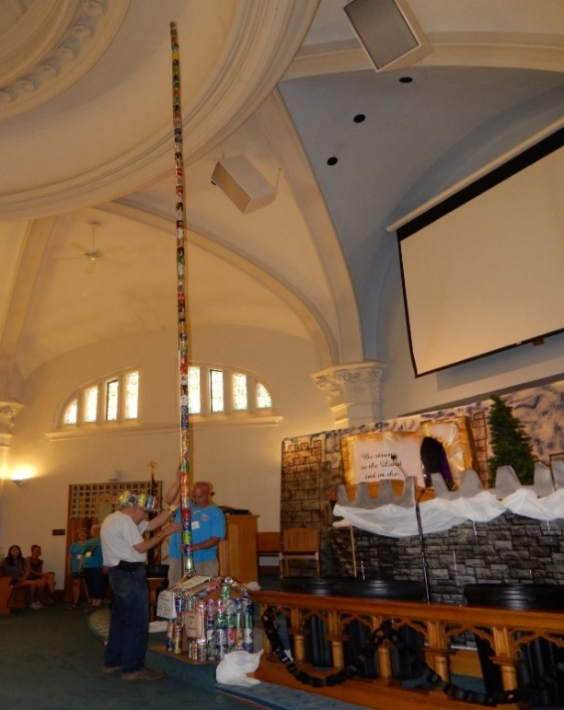

2022 VBS CANS FOR HABITAT
58,872 cans=58 cans in chimney-24 feet high.
If laid end to end would reach over 4 ½ miles.
27 year total=913,267 cans.
If laid end to end would be 72 miles long.


2023 VBS ALUMINUM CANS
FOR HABITAT FOR HUMANITY
Our aluminum can collection for Habitat for Humanity for VBS 2023 has started. Since the end of VBS 2022 (June 24) through July 15 we have received 2,555 cans.
Many thanks to everyone who is saving aluminum cans and bringing them to church-at the ramp at the back of the church.
If you haven’t been saving aluminum cans, please start saving-soft drinks, juice, power drinks, tea, beer, cat food – ALUMINUM ONLY—NOT “TIN CANS” food, soup, etc…
Call the church office 724-548-4312 or me 724-548-7124 or 724-859-0819 if you need a can pick-up. Thank you, The Can Man, Jim Ternent


STAMPS FOR CARING FRIENDS
Caring Friends sends out a lot of cards each month. With the price of stamps going
up again, we are asking if anyone wants to help out with a donation of a book of stamps or
money towards stamps. It would be greatly appreciated. Thank you


AUGUST MISSIONS
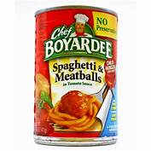
We will be collecting cans of Chef Boyardee (or other brands) of Ravioli,
spaghettios, spaghetti & meatballs, etc.. for our August project. This will provide a bag
filled with easily accessable food items for grade school children who do not have
enough food on a weekend. Let’s be a helping and giving hand for these children.

FIRST CHURCH LINK PAGES

VBS 2022 STAFF LIST Knights Of North Castle

We would like to thank the following for their help before and during Vacation Bible School. VBS could not happen if we didn’t have the dedicated volunteers listed below. Some helped just a day or two but many helped every day.
Pre-School: Kim Yankasky, Pam Shaffer, Natalie Kamer
PreK: Cindy Volek, Susan Ferguson, Gabi Zielinski
Kindergarten: Brenda Beers, Lu Bennett
First Grade: Melissa Bureau
Second Grade: Donna Lazan, Carlee Beers
Third Grade: Abby Yankasky
Fourth Grade: Vicky Fotheringham
Fifth & Sixth Grade: Bonnie Bowser, Rachel Stockdill
Bible Story: Mary Jo Lipski
Lesson Application: Brad Hellein (Dr. C. L. Helium), Mert Hellein

Crafts: Sue Hankey, Steph Hankey, Lynn Sibley

Games: Merissa Smith, Isaac Zielinski, Peyton Zielinski

Music: Emily King

Snack: Sarah Heckert, Kathy Coleman, Kathy Piechowicz

Can Man: Jim Ternent, Ken Lazan (Drop cans off at the ramp anytime all year)

Offering Counter: Audrey Green

Opening and Closing: Pastor Deb Kociban, Sparky (Steph Hankey)

Photographer: George Kociban

Registration: Carolyn Hancock, Audrey Green, Merissa Smith

Scenery/Decorations: Audrey Green

Sound System: George Kociban

VBS Coordinator: Sue Hankey

THANK YOU TO THE FOLLOWING: Helping to decorate the church and set up the tent Saturday morning; Brenda Beers, Mark & Susan Ferguson, Audrey Green, Rob & Sue Hankey, Joe & Sarah Heckert, Caitlyn & Valerie Kachur, Lynn Sibley, Gabe, Maddie & Merissa Smith, Jim Ternent

Also, Thank You to the Congregation for the generous offerings and the donations of snack items, and CANS, CANS, CANS. Thanks to Barb Sowers for making the daily posters.

And finally, THANK YOU to the parents and families of the children for bringing their children each day, they are the reason we all had such a good week.

FORD MEMORIAL LINK
B2B BIBLE SCHOOL
AUGUST 8-12 FROM 6:30-8:00 PM
Get Back 2 Basics Bible School is focused on teaching some Basic Bible Lessons.
All ages welcome.
AUGUST BIRTHDAYS
5 Betty Simmons
11 Nathan Kamer
19 Janice Bernot




MANORVILLE LINK PAGE

AUGUST BIRTHDAYS
2 Rev. Thom Bonomo
3 Brianna Conklin Huth
4 Darcy Gaul Toy
6 Steve Arblaster (dad)
7 Daria Petrie
7 Casey Welch
11 Lori Walker
14 Brittany Walker
16 Michael Anderson
17 Rick Orton
17 Cindy Hill
22 Rachel Wrona-Rowe
29 Mike Querry

AUGUST ANNIVERSARIES
21 Carol (Reesman) & Steven Snyder-16 years
26 Natalie (Perrott) & Chris Toy-17 years

MANORVILLE
FINANCIAL COUNTERS
August 7th- JB & Jack
August 14- Mike & Lu
August 21- Nancy & Nancy
August 28- Steve & Lu



UNION AVENUE LINK PAGE
AUGUST BIRTHDAYS
14 Vesta Csir
14 Sharon Ulisky
17 Rose Mazzota
19 Ruth Gallaher


AUGUST ANNIVERSARIES
9 Dick & Peggy Say-65 years


