

“I give you a new commandment: Love each other. Just as I have loved you, so you also must love each other. This is how everyone will know that you are my disciples, when you love each other.” John 13: 34-35 (CEB)
Pastor Deb’s
Message

Dear Brothers and Sisters in Christ,
I remember way back when our daughter was just beginning to learn her first words. Her first two words, after learning Dada and Mama, were “shoe” and “bubbles.” I have no idea why she chose these as being important enough to speak. I do know that George and I made great efforts to teach her to say, “thank you.” I can’t tell you how many times we must have said to her, “What do you say?”, as our prompting for those two words of gratitude to be spoken.
When Jesus came to earth, his one mission was to save us from sin and to reconcile us to God. He would need to begin that mission by teaching his disciples a new language, a new word that they would have to live out every moment. That word was “love.” Jesus would show us the depth of meaning of that word, love, when he died on the cross for us. Love for God and love for one another requires that we all make the ultimate commitment to God and to each other. Loving each other with all our foibles and all our faults is never easy, but it is our greatest joy to know that when we are the family of God we are loved just as we are. Loving each other requires us to think of our brothers and sisters and their needs before our own and then doing something to fulfill those needs.
Whitney learned to say “thank you” both sincerely and often. Those two words are a vital part of the vocabulary of love. So, it is with grateful hearts that George and I say “thank you” to all of you across the charge. Your prayers, your cards, your flowers, your food, your expressions of love and care for us at the loss of George’s mom were graciously given at a time when our world was upside-down. You reminded us that the power of God’s love never fails to bring healing and joy to broken hearts. Thank you.
With love and grateful hearts,
George and Pastor Deb

Pastor Brenda’s
Message
FRIENDS WITH EACH OTHER
John 15:15 “I no longer call you servants, but call you
friends.”
As Christians we have a peace with God. We need to
keep this in mind as we deal with others around us, that same peace should be shared. With God all things are possible. Peace between family, peace between countries and peace at home. God is a friend not a foe. This kind of peace only comes with the Lord’s help at times. This begins with each of us doing our part . Really pray about this and see how God’s love will grow in you and around you. We serve a God of LOVE and PEACE.

OCTOBER LECTIONARY READINGS

October 6, 2019
11:00 AM
17th Sunday after Pentecost
Lamentations 1:1-6, Psalm 137
2 Timothy 1:1-14, Luke 17:5-10

October 13, 2019
18th Sunday after Pentecost
Jeremiah 29:1, 4-7, Psalm 66:1-12
2 Timothy 2:8-15, Luke 17:11-19

October 20, 2019
19th Sunday after Pentecost
Jeremiah 31:27-34, Psalm 119:97-104
2 Timothy 3:14-4:5, Luke 18:1-8

October 27, 2019
11:00 AM
20th Sunday after Pentecost
Joel 2:23-32, Psalm 65
2 Timothy 4:6-8, 16-18, Luke 18:9-14

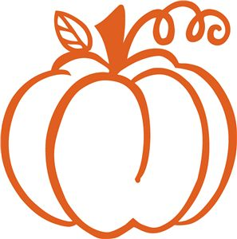
(Manorville)
FINANCIAL TEAMS
6 Lois Hawk & Kay Rupp
13 Jim Boarts & Jack Bennett
20 Bob & Dianna Brocious
27 Judie Reesman & Luella Bennett

USHERS
6 Mike Snyder & Jim Boarts
13 Lois Hawk & Nancy Gaul
20 Sandy McKee & Lynn Sibley
27 Steve Arblaster & Chuck McNabb

DONUT SPONSORS-2019
October- Jack & Lu Bennett
November-Mike Snyder
December-JB& Nancy

(Cost is $25, donuts have increased in price to $26.97. You are asked to please clean up afterwards. Thank you!)

(First Church)

WELCOME CENTER READERS

6 Sarah Heckert 6 Natalie Green
13 Melissa Flanders 13 Jim Ternent
20 Karen Scaife 20 Kathy Piechowicz
27 Beverly Patton 27 Mary Jo Lipski



SOUND SYSTEM COUNTERS
6 Bill Lemons 6 Yankasky
13 Tim Scaife 13 Flanders
20 Gabe Smith 20 McKelvey
27 Dave Yanoschick 27 Scaife

USHERS
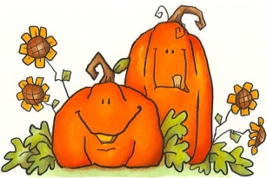
6 Asbury/Mary Jo Lipski & Communion
13 Asbury/Mary Jo Lipski
20 Epworth/Melissa Flanders
27 Epworth/Melissa Flanders



BELL RINGERS ACOLYTE
6 Carlee Beers 6 Carlee Beers
13 Chelsea Beers 13 Joey Kachur
20 Caden King 20 Ryan Bish
27 Jocelyn King 27 Isaac Zielinski
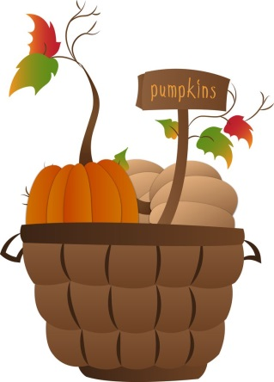

ARC CHARGE CONFERENCE
The ARC Charge Conference will be held on Wednesday, October 16th at 7:00 PM at First UMC in the sanctuary. Suzy and Byron will lead us in a time of worship before we begin the meeting. Rev. Jim Pond will meet with members of all SPRC, Nominations committees and Lay Leaders at 6:00 PM. Please plan to attend.

OCTOBER BIRTHDAYS & ANNIVERSARIES

FIRST CHURCH
BIRTHDAYS
2 Brandon Schrecengost 15 Brad Volek
6 Sierra Aires 17 John Yankasky
6 Norm King 18 Kaitlin Edwards
6 Patrick Wolfe 20 Lindsay Harkleroad
7 Matthew Kachur 21 Rick Reefer
10 Frank Kiss 21 Rowan Vandevort 4
10 Mark Porter 22 Lance Zielinski
11 Melissa Flanders 26 Ada Bowser
14 Laurie Lemons 28 Ryan Cornman
14 Harry Waldenville 29 Fay A Asay
15 Jazmine Hicks 30 Hayley Hoffman

FIRST CHURCH
ANNIVERSARIES
1 Pastor Brenda & Chet Schall-3 years
3 James & Diane Weibel
8 Ryan & Sally Cornman-8 years
8 Ken & Barb Gaughan-42 years
12 Larry & Janet McKelvey-17 years
16 Ryan & Crystal Zier-9 years
24 Matthew & Jolena VanMeter-5 years
30 Rob & Sue Hankey-38 years




MANORVILLE
BIRTHDAYS
9 Jeanette Dotts 14 John Czapor II
9 Paige Reesman 18 Owen James Branan
9 Belinda Olinger 21 Richard Dotts
9 Ed Zielinski 24 Gabriel Lytle
13 Maria L. Brocious Corbett 29 Dianna Brocious

MANORVILLE
ANNIVERSARIES
9 Jack & Luella Bennett
27 Darcy & Shawn Toy



UNION AVENUE
BIRTHDAYS
11 Clair Lundberg
19 Gary Wyant Jr.
20 Dave Wolfe
21 Carol Ingram
30 Peggy Say

ANNIVERSARIES
3 Scott & Debbie Eberle
4 Clair & Marilyn Lundberg
10 Bill & Carolyn Ingran


FORD MEMORIAL
BIRTHDAYS
1 Brenda Berrett
6 Caleb Berrett
11 Lowell Simmons
13 Connie Bish
27 Brodie Lemmon
30 Clara Beckett



FORD MEMORIAL
ANNIVERSARY
23 Amanda & Dave Dingey


We extend our Christian Compassion and concern to:
~~George Kociban and his family on the death of his mother, Mary Louise Kociban. Mary Louise passed away on Monday, August 26, 2019. She was the mother of George (Pastor Deb) Kociban and Mary, grandmother to Whitney Kociban and Mary Elizabeth
Fry.
~~The family of Rev. Jacqueline “Jackie” Bish. Jackie passed away on Saturday, September 7, 2019. She was a member of the PA Conference of the United Methodist Church and was affiliated with the First United Methodist Church in Kittanning. She was the mother to Jeannette (Fred) Steiger, Christine (Frank) Pastva, and Robin (Frank) Myerski; step mother to David (Linda) Bish, Douglas (Karen) Bish and Vickie Bish.


MISSIONS AND MISSIONS UPDATES
OCTOBER MISSIONS “UNDIES SUNDAYS”
That’s right. You read it correctly! Our church charge family will join together in October to collect underwear for the House of the Carpenter in Wheeling, W.VA. We will provide underwear for their men & women, boys & girls—any and all sizes, brands, colors, styles. This is the first time we have had a mission collection of “unmentionables”. But, dear friends, if we really care about people and learn they do not have enough money for underwear, isn’t it a caring, “foundational” gesture to provide underwear?!
We learned from Dr. Mike Linger this mission has a tremendous need for undergarments. Our brothers and sisters who live in poverty use their money to buy tops and shirts, pants and jeans – not underwear. Underwear is not a “must”, but…it is nice. It provides support, warmth, protection, and a sense of well-being. Personally this Missions Committee has always liked underwear!
No need to be “brief” about it. We want dozens and dozens of BVDs, boxers, underpants, undershirts, drawers, bikinis, sports bras, regular bras, long johns and even bloomers! So shop and let’s give and love generously! Remember, we are “undergirding” people with dignity and love. Bring your items into your church and we will collect them on November 11th.

Remember Jesus’ words in Matthew 25 “…For I was hungry and you gave me something to eat, I was thirsty and you gave me something to drink, I was a stranger and you invited me in, I needed clothes and you clothed me, I was sick and you looked after me, I was in prison and you came to visit me…” Church family, let us listen to Jesus’ words and act on them as we clothe the ones who need clothes.

2020 VBS ALUMINUM CANS
(First Church)
For Habitat for Humanity
Our aluminum can collection for Habitat for Humanity continues.
We invite our sister churches to join in our aluminum can

collection. I will supply a collection container for each church that is interested and pick up their cans monthly. If your church is interested, let me know 724-548-7124 or 724-859-0819.
Cans received (August 15-September 15) 5,073
Cans received since end of VBS (June 21st,) 9,230
Please continue or start saving aluminum cans of all sorts (pop, tea, fruit juices, health drinks, power drinks, beer and any other type of aluminum cans).
Drop them off at the ramp behind the church at any time. Thanks to the folks at Arc Manor for continuing to save their 290 drink cans and to be in Mission with us.
Thank you Union Avenue for 52 cans. Also-thank you someone for 551 crushed cans. Thank you, The Can Man (Jim Ternent)

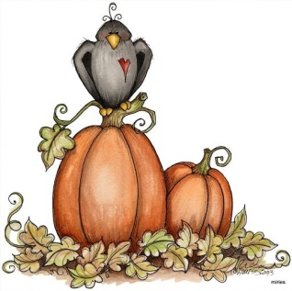
YOU’RE INVITED!!!
Please consider joining the FUMC Missions Team on a volunteer opportunity to serve dinner at Light of Life Rescue Mission in Pittsburgh.
WHEN: Saturday, October 26th
VOLUNTEER SHIFT: 4:15-6:30 PM
DEPART FROM COVENANT CENTER: 3:15 PM
WHERE: 10 E North Avenue Pittsburgh, PA 15233 (North Shore)
MORE INFORMATION: https://www.lightoflife.org
INTERESTED? - Contact: Janet (724) 543-5855, Meaghan (724) 664-7554, or Kathy (724) 965-6456


UPDATES ON MINISTRIES


OCTOBER SIFT LUNCHEON
Thursday, October 17, 2019
Covenant Center
MENU: Vegetable Soup, Grilled Cheese Sandwich, Relish Plate, Gingerbread
PROGRAM : Dave’s Accordion Music, Music
by Dave Palezney
RESERVATIONS DUE BY
Monday, October 14th

ALL-U-CAN EAT SPAGHETTI DINNER
(Manorville)
All U can eat spaghetti dinner will be November 2, 2019 from 4:00-6:30 PM. Adults $8.00, youth 6-12 years $4.00 and age 5 and under free. Includes salad, bread, drink and dessert. Bring your family, friends and neighbors. Proceeds go towards missions. We need helpers! Call Luella to sign up to work and/or bring desserts. Financial donations are also accepted.



FRIDAY NIGHT CIRCLE
Thursday, October 10, 2019
7:00 PM-Covenant Center
PROGRAM: Cindy McShane portrays Marie Tepe, A Vivandiere for the Union Army
DEVOTIONS: Kathy Riffer
HOSTESSES: Beverly Patton, Janet McKelvey




TURKEY DINNER
(First Church)
FRIDAY, NOVEMBER 8TH
4:30-6:00 PM
Turkey with all the trimmings
MANORVILLE CONGREGATIONAL TURKEY DINNER
(Manorville)
Saturday, November 9, 2019
6:00 PM
We’re trying something new this year with Judie in CA and won’t be here to tell us what to do and when!
It will be catered for the main foods but we will still do the Cole Slaw, Sweet Potatoes, noodles, bread and we ask for people to bring desserts.
You are asked to pay $4.00 a meal, children 6 and younger are free. Cash or check made out to “MUMC Nurture” can be given to Lisa Czapor or Lu Bennett when you sign up. Sign up is necessary this year so we know how many dinners
to order.
Sign-up sheet will be on the
back window in October. Make sure
you mark your calendar and join us
for this festive meal.

CASUAL CHURCH
(Manorville)
Wednesday, October 9, 2019
6:00 PM
Program: Michael Coats.
Menu:Free chicken and biscuit dinner with vegetables, desserts and drinks.
For more information, call Sandy McKee 724-763-9494





THANK YOU’S
Dear Union Avenue United Methodist Women,
On behalf of the Ruth M. Smith Center, I would like to acknowledge a gift of $200.00 through your combined donations supporting the WPAUMC's Mission Ambassadors. Your support is greatly appreciated and allows us to continue our mission to care for area children and to assist the elderly and physically or intellectually challenged adults. Thank you again for your generosity, support and continued prayers for the Ruth M. Smith Center.
Sincerely, Kimberly G. Adams, Interim Executive Director

Dear Union Avenue United Methodist Women,
Thank you for your $100.00 gift to my ministry. Your long-term investment these many years has impacted innumerable lives across Honduras and beyond. Serving God's Kingdom with you.
Laurie J. Potter, World Gospel Mission.

Dear Union Avenue United Methodist Women,
We give thanks to God that so much has been accomplished in the past because of your support, and we look forward to the things that will be accomplished because of your generous partnership. Thank you for your monetary gift of $100.00. May God's blessings pour out on your community because of your kind hearts.
Kari Collins, Executive Director
Red Bird Mission, Beverly, KY

Thank you for all the birthday greetings, cards, calls and prayers. I really enjoy everything and it helps me get through the day. Anna Pickett

What a blessing to have “caring friends” tho they are far away-love keeping up with you on Facebook.
I am improving-getting around with a walker, pain is less every day. Hearing from you always brightens my day-sending love and prayers to all. Jean Wolfe

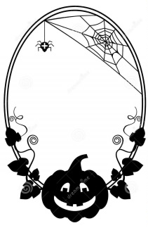
SUNDAY SECURITY
(First Church)
We now live in a world where acts of terrorism are commonplace and we must consider security for our congregation. Beginning Sunday, October 6, 2019 the ramp and Vine Street doors will be locked at 11:10 AM. There will be signs on these doors directing worshipers to the front door where an usher will admit you.
Thank you for adapting to our new normal. Trustees
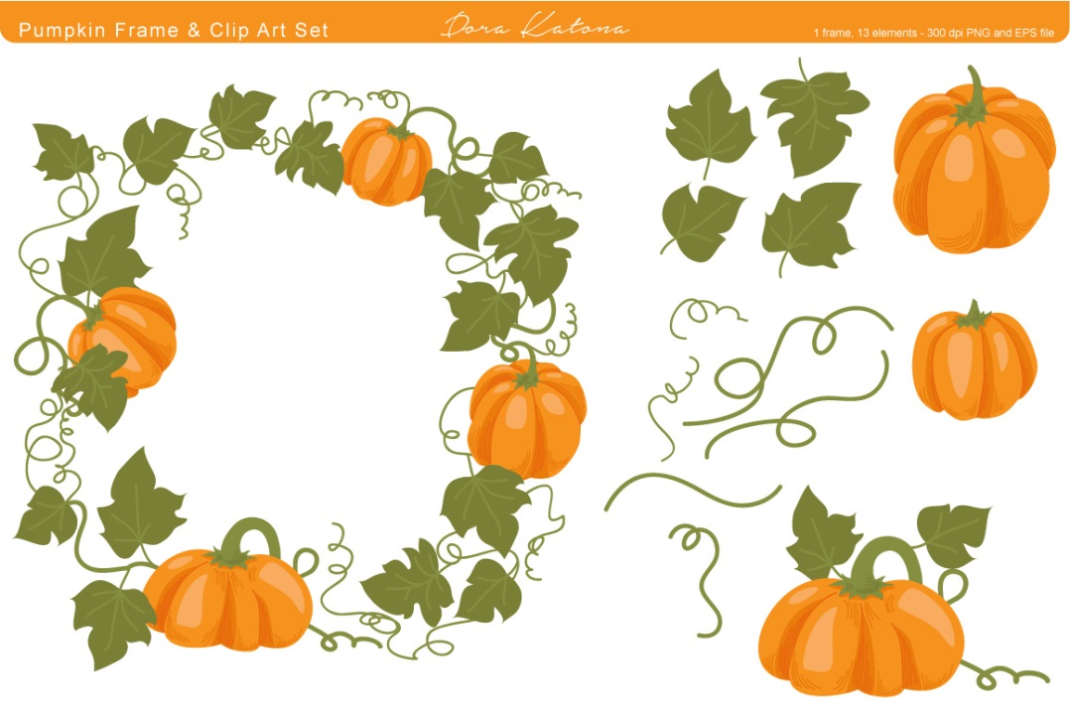
SOUP AND SANDWICH MEAL
(Ford Memorial)
The Soup and Sandwich meal at Ford Memorial will be offered only on the FIRST and THIRD Thursdays of the month, 4:00-6:00 PM

FINANCIAL UPDATE
(First Church)
September Financial
Update is available in the
Church office for all
Interested members.

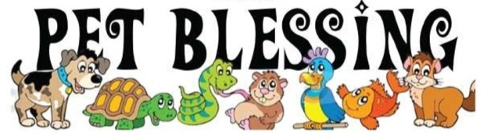

Pastor Deb will be doing a blessing of the pets at the Fall for Animals Festival Saturday, Oct. 12 @ 2:00PM at the Crooked Creek Horse Park. Fall for Animals Festival is an outdoor craft and vendor show which benefits local animal rescue organizations, there is a $5 parking fee with all proceeds going directly to help pets in need. All ages and leashed pets welcomed.

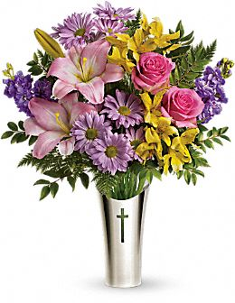
PASTOR APPRECIATION 2019
October is Pastor Appreciation Month and the Staff Parish Committee asks that you show your love and appreciation to both Pastor Deb and Pastor Brenda.
The Allegheny River Charge churches have been blessed by the presence of both of our leaders and as Paul tells us, “Let the elders who rule well be considered worthy of double honor, especially those who labor in preaching and teaching.” (1 Timothy 5:17)
Please set aside some time, especially this month, to express your gratitude to each of our pastors. Perhaps you can send a personal note or better yet express your thanks in person, and as always, we ask that you remember each in your daily prayers.

Be sure to let Pastor Deb and Pastor Brenda know that you appreciate their never-ending labor in the name of God.

UNITED METHODIST WOMEN REPORT
(Union Ave)
The September 9, 2019 meeting was held in the Community Room at the Kittanning Cottages with 9 in attendance. The meeting opened with the reading of the purpose of the United Methodist Women led by president Karen Wolfe.
Our hostess for the meeting was Donna Titus. Devotions were by Karen Wolfe entitled “In the Beginning There was Light”. Lynn Sibley did the Minute Missions for Sandy McKee who was not feeling well-get well soon Sandy! We missed you! the title of the Minute Missions was “The 4 Footed Ministry”. The prayer calendar was also presented by Lynn Sibley.
The secretary’s and treasurer’s reports were read and approved.
Under Old Business: We made 78 school kits and they were delivered to the Mission Barn by Donna & Bruce Shaffer. We received thank you letters from Red Bird Missions for a $100.00 donation and also from the Ruth M. Smith home for a $200.00 donation.
New Business:
1. The annual meeting of the Indiana District of the UMW will be held on September 21, 2019 in
Brockway. The theme will be “Sisterhood of Grace-International Day of Peace.”
2. Election of officers for 2020. All current officers will retain their positions for 2020.
3. It was decided to complete our pledge for 2019 to the district UMW as well as sending 5 cards-
Thinking of you and Memory cards to 5 individuals and to vote on who will receive the UMW
service pin for 2019.
4. A motion was made and motion passed to give $100.00 to the Turkey Fund and $250.00 for our
Christmas family through the Community Action Agency.
5. Union Ave. women will have a bake sale of Cinnamon Rolls in October. Price is $1.00 each and we
will be taking orders for the Cinnamon Rolls. The date for pick-up will be October 20, 2019 at the
church at 10:00 AM.
6. Will be planning our Christmas Party for the first Monday in December. Decision made to have it
catered by the Adrian Store.
The meeting closed with the reading of the UMW’S prayer.
Secretary, Ellen Nelson

