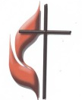
FIRST UNITED METHODIST CHURCH
NON-PROFIT ORG.
U.S. POSTAGE
PAID
KITTANNING PA 16201
PERMIT NO 14
301 NORTH JEFFERSON STREET
KITTANNING PA 16201
CHURCH OFFICE: 724-548-4312

ADDRESS SERVICE REQUESTED

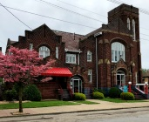
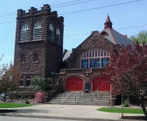
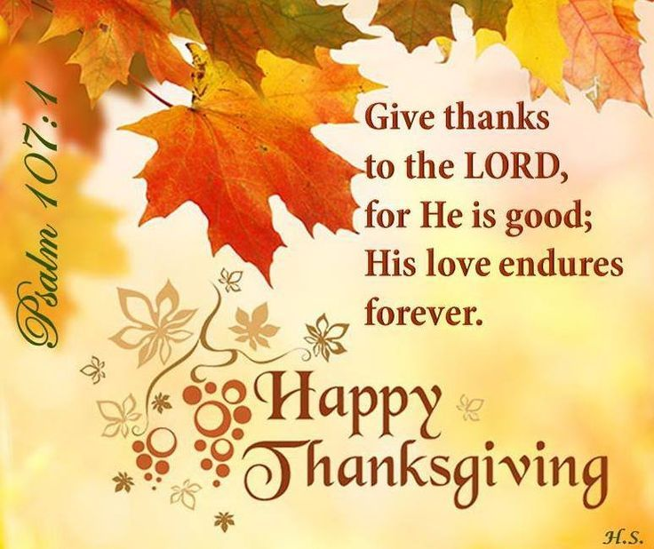

ARC LINK NEWSLETTER
NOVEMBER 2019

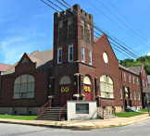
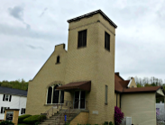

ALLEGHENY RIVER CHARGE
Senior Pastor: Rev. Deb Kociban Associate Pastor: Brenda Sommerville Schall

First United Methodist Church-301 N Jefferson Street, Kittanning PA 16201 724-548-4312
Sunday School 9:30 AM Worship 11:00 AM Email:fumchurch@windstream.net
Office Hours: Monday-Thursday 8:00 – 4:00 PM Website: firstchurchkittanning.com
Fax: 724-548-5157 Rainbow Road: 724-543-7569
Parsonage- 307 N Jefferson Street, Kittanning PA 16201 724-543-4808

Ford Memorial United Methodist Church-1024 Fourth Ave, Ford City PA 16226 724-763-1540
Sunday School 9:15 AM Worship 11:00 AM Email: fordmemc@comcast.net

Manorville United Methodist Church-P.O. Box 174, 800 Water Street, Manorville PA 16238
Adult Sunday School 9:15 AM Youth Sunday School 9:45 AM Worship 9:45 AM
Email: mumc@windstream.net 724-763-1254

Union Avenue United Methodist Church-421 Union Ave, Kittanning PA 16201
724-543-5012 Worship 9:00 AM Sunday School 10:15 AM







DECEMBER NEWSLETTER DEADLINE,
Please get articles to Audrey no later than
SUNDAY, NOVEMBER 17TH. Thank you




“Walk into the fields and look at the wildflowers. They don’t fuss over their appearance-but have you ever seen color and design quite like it?...If God gives such attention to the wildflowers, don’t you think he’ll attend to you, take pride in you, do his best for you?” Luke 12: 25- 28
Pastor Deb’s
Message

Dear Brothers and Sisters in Christ,
I just bought a new pair of red sneakers, all red sneakers. It’s quite a color to see every time I move my feet. I have noticed that as I am maturing, I seem to be drawn to color more and more. Vibrant, bold colors make me smile. Now that I have my new sneakers, I smile more as I walk.
In this passage of Luke, Jesus is remarking to his disciples how God has designed and colored the wildflowers of the field. God took care in choosing each color and arranging every petal so that flowers of the field would cause God’s people and God himself smile. Then God continues to care for them by sending the sun and rain to nourish and grow them, all without the flowers having to do anything themselves. If God will do this for the flowers of the field, won’t God also take care of us, providing all that we need and then showing us off as the jewel of God’s creation?
In this month of thanksgiving let us all be more attentive to the ways in which God has provided for us from choosing the color of our eyes to designing our very lives. And as Jesus has said, God will always provide for us in every way. God does this because God loves us and for that we offer our thanksgiving not just on one Thursday of the year, but on every single day of every single year.
Let’s look for the color in our lives this month. From the leaves on the trees, the pumpkins on the porches, to the eyes of our loved ones, all given to us by our gracious God. Let us offer our gratitude to our God who colors our lives with God’s love.

I have a pair of red sneakers! With every step I take I will offer to God my thanks and praise for God’s loving care. May you find your own ‘red sneakers’ and offer to God your thanksgiving.
Blessings, Pastor Deb
NOVEMBER LECTIONARY READINGS

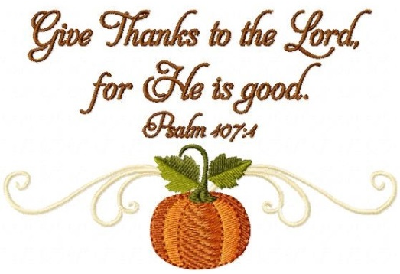
November 3, 2019
11:00 AM, All Saints Sunday
21st Sunday after Pentecost
Habakkuk 1:1-4, 2:1-4, Luke 19:1-10
Psalm 119:137-144,
2 Thessalonians1:1-4, 11-12

November 10, 2019
11:00 AM
22nd Sunday after Pentecost
Haggai 1:15b-2:9, Luke 20:27-38
Psalm 145:1-5, 17-21
2 Thessalonians 2:1-5, 13-17
(Pastors Deb & Brenda switch pulpits)

November 17, 2019
11:00 AM
23rd Sunday after Pentecost
Isaiah 65:17-25, Isaiah 12 or Psalm 118,
2 Thessalonians 3:6-13, Luke 21:5-19
(Sandy McKee speaker at Manorville)

November 24, 2019
11:00 AM
Christ The King Sunday
Jeremiah 23:1-6, Luke 1:68-69,
Colossians 1:11-20, Luke 23:33-43

(Manorville)
FINANCIAL TEAMS
3 Lois Hawk & Kay Rupp
10 Jim Boarts & Jack Bennett
17 Bob & Dianna Brocious
24 Judie Reesman & Luella Bennett

USHERS
3 Chuck Coffman & Mike Snyder
10 Lois Hawk & Nancy Gaul
17 Jim Boarts & Chuck McNabb
24 Sandy McKee & Lynn Sibley

DONUT SPONSORS-2019
November-Mike Snyder
December-JB& Nancy

(Cost is $25, donuts have increased in price to $26.97. You are asked to please clean up afterwards. Thank you!)

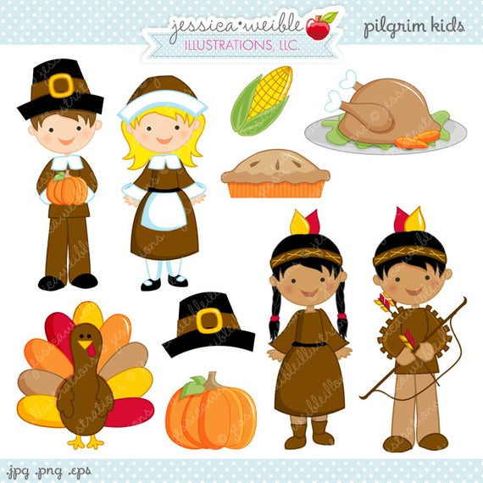
(First Church)
WELCOME CENTER READERS
3 Sarah Heckert 3 Lynn Haught
10 Melissa Flanders 10 Sarah Heckert
17 Karen Scaife 17 Janet McKelvey
24 Beverly Patton 24 Mert Hellein
SOUND SYSTEM COUNTERS
3 John Yankasky 3 Williamson
10 Tim King 10 Ternent
17 John Wolfe 17 Yankasky
24 Bill Lemons 24 Flanders

USHERS
3 Oxford/Mark Ferguson & Communion
10 Oxford/Mark Ferguson
17 Albright/Dan Wolfe
24 Albright/Dan Wolfe
BELL RINGERS ACOLYTE
3 Ashley Yankasky 3 Hallie Hoffman
10 Madelyn Smith 10 Ashley Yankasky
17 Evva Yanoschick 17 Evva Yanoschick

24 Logan Green 24 Chelsea Beers
DECORATING CHURCH FOR CHRISTMAS
First Church
Tuesday
November 26th
8:30 AM

Manorville
Sunday, November
24th with Pizza lunch

NOVEMBER BIRTHDAYS & ANNIVERSARIES

FIRST CHURCH
BIRTHDAYS
1 Tim King 14 Killian Vandevort 3
4 Logan Green 16 Grace Edwards
4 Cindy Volek 18 Sarah Heckert
6 Karen Scaife 19 Jack Heim
9 Christopher Hankey 19 Diane Weibel
9 Greg Lemons 20 Tony Krozely
11 Joshua Fiscus 20 Anita Smith
11 Katie Smith 20 Greg Toth
12 Noelle Lemons 21 Peyton Zielinski
13 Rachel Snow 22 Mert Hellein
14 Sarah Fiscus 29 Kelly Hoffman


FIRST CHURCH
ANNIVERSARIES
1 Bruce & Jayna & Harkleroad
13 Pastor Deb & George Kociban
15 Harry & Michelle Waldenville-22 years
25 Fred & Gail Blaney-58 years
26 Roy & Bobbie Williamson-59 years





MANORVILLE
BIRTHDAYS
1 Cameron Lewis Welch 22 Catherine Waldenville
4 Randy Reesman 28 Elaine Waldenville
6 Joshua Walker 28 Nicole Zielinski
6 Tessa Shaul 30 Carol (Reesman) Snyder
11 Heather Arblaster 30 Natalie Toy
20 Xenia Zielinski

MANORVILLE
ANNIVERSARY
26 Mike & Paige Querry



UNION AVENUE
BIRTHDAYS
2 Lori Goepfert
8 Donna Titus
18 Marilyn Lundberg
21 Corey Shaffer
24 Vaila Clever
24 Viera Clever

FORD MEMORIAL
BIRTHDAYS
3 Melissa Palm
23 Fred Burdett-91 yrs
25 Mary Wiles
25 Shirley Bryan



FORD MEMORIAL
ANNIVERSARIES
8 Eva & Jim Say
22 Shirley & Mark Bryan






We extend our Christian Compassion and concern to:
~The family of Rev. Robert (Bob) Lash. Rev. Lash passed away on Sunday, September 22, 2019. He was the pastor of First Church from 1963-1969. He was the father to Kathy Lash Fuller and Rita Lash.

~Darla Bernot and her family on the death of her husband Bill Bernot. Bill passed away on Saturday, October 5, 2019. He was a member of Ford Memorial UMC.

(First Church)
On Sunday, October 6, 2019 we welcomed Gary Howgg, Jeff & Pam Shaffer and Joseph & Laura Mauger into our Church family.




TAX SEASON?
Did you know that money given directly from your IRA to a qualified charity like your local church does not count as federal taxable income? If you are taking distributions from your IRA and then using that income to give to the church, that money is then taxable income. It is especially important in our retirement years to make the most of the finances that God has given us. You may want to take advantage of the IRA Charitable Rollover as authorized by Section 408(d)(8) of the Internal Revenue Code for a once-yearly donation saving you taxable income money. Please contact your financial advisor for more information or you may pick up more information in the First Church office.

MISSIONS AND MISSIONS UPDATES



2020 VBS ALUMINUM CANS
(First Church)
For Habitat for Humanity
Our aluminum can collection for Habitat for Humanity continues.
We invite our sister churches to join in our aluminum can
collection. I will supply a collection container for each church that is interested
and pick up their cans monthly. If your church is interested, let me know
724-548-7124 or 724-859-0819.
Cans received (September 15-October 15) 4,485
Cans received since end of VBS (June 21st,) 13,715
Please continue or start saving aluminum cans of all sorts (pop, tea, fruit juices, health drinks, power drinks, beer and any other type of aluminum cans).
Drop them off at the ramp behind the church at any time. Thanks to the folks at Arc Manor for continuing to save their 139 drink cans and to be in Mission with us.

Also, thank you to known friends from outside our church who brought in bags of 666, 287, 159 and 346 cans. Thank you, The Can Man (Jim Ternent)

NOVEMBER MISSIONS
(First Church)
Our Missions ministry is devoted to reaching out near and far to meet needs of God’s dear people. In September, the “Rise Against Hunger” rice packets were shipped to Zambia, a land-locked country in South Central Africa. Our “UNDIES SUNDAYS” collection will soon be taken to the House of the Carpenter in Wheeling, W.V. where people will be able to purchase them at very low prices.
NOVEMBER’S PROJECTS WILL OFFER TWO DIFFERENT CHOICES:
1. Operation Christmas Child Shoeboxes are available on the altar rail. Be sure to get the boy/girl label, a prayer card and “how to pack the box”. No toothpaste or candy is allowed. Remember to include the $9 as it covers shipping and handling. You may opt to give online through FOLLOW YOUR BOX and find the destination of your shoeboxes. The National Collection Week is November 18-25, so our deadline is SUNDAY, NOVEMBER 17TH. No exceptions.
2. Our local FOOD BANK-starting November 10th, tables will be provided for us to place canned goods and non-perishable food items on for needy families in our area. Especially needed are: peanut butter, cans of tuna, canned fruit. Give generously so others may have food.
May your heart and soul be blessed as we send love (in practical ways) to those who are in need. Blessings, Your Missions Committee


UPDATES ON MINISTRIES

TURKEY DINNER
(First Church)
Our annual Turkey Dinner will be Friday, November 8th from 4:30-6:00 PM. Adult meal including pie is $9.00, Child’s meal ages 4-12 is $4.00. If you can bake pies, please call June Pollard (724-543-4920). Any donations toward buying turkeys can be marked “turkey dinner” and placed in the offering plate. Half of the profits will be sent to House of the Carpenter.


ALL-U-CAN EAT SPAGHETTI DINNER
(Manorville)
All-U-Can-Eat spaghetti dinner will be November 2, 2019 from 4:00-6:30 PM. Adults $8.00, youth 6-12 years $4.00 and age 5 and under free. Includes salad, bread, drink and dessert. Bring your family, friends and neighbors. Proceeds go towards missions. We need helpers! Call Luella to sign up to work and/or bring desserts. Financial donations are also accepted.

MANORVILLE CONGREGATIONAL TURKEY DINNER
(Manorville)
Saturday, November 9, 2019
6:00 PM
We’re trying something new this year with Judie in CA and won’t be here to tell us what to do and when!
It will be catered for the main foods but we will still do the Cole Slaw, Sweet Potatoes, noodles, bread and we ask for people to bring desserts.
You are asked to pay $4.00 a meal, children 6 and younger are free. Cash or check made out to “MUMC Nurture” can be given to Lisa Czapor or Lu Bennett when you sign up. Sign up is necessary this year so we know how many dinners
to order.
“Reservations due to Lisa or
Luella by November 3rd”
POPCORN TIME
It is popcorn time again. Linda Scaife will have order forms for you to look at.
Profits go to Rainbow Road. The popcorn is delicious and comes in a variety of flavors. Orders are due by Thanksgiving and will be here before Christmas.






SOUP AND SANDWICH MEAL
(Ford Memorial)
The Soup and Sandwich meal at Ford Memorial will be offered only on the FIRST and THIRD Thursdays of the month, 4:00-6:00 PM


CASUAL CHURCH
(Manorville)
Wednesday, November 13, 2019
6:00 PM
Program: Cierra Anthony
Menu: Free homemade soups, bread, crackers, desserts and drinks.
For more information, call
Sandy McKee 724-763-9494


GAME NIGHT
(First Church)
The Fellowship Committee will be holding a game night in the Covenant Center on Saturday, November 23, 2019 from 6:00-9:00 PM.


NOVEMBER SIFT LUNCHEON
Thursday, November 21, 2019
Covenant Center
MENU: Turkey, Stuffing, Mashed Potatoes, Gravy, Corn, Green Beans, Cranberries, Rolls & Butter, Cake
PROGRAM : Antarctica Travelogue presented by Mary Jo Lipski
RESERVATIONS DUE BY
Monday, November 18th
FRIDAY NIGHT CIRCLE
Thursday, November 14, 2019
7:00 PM-Covenant Center
PROGRAM: Thanksgiving Pot Luck Dinner,
Christmas Family Planning
DEVOTIONS: Linda Cornman
HOSTESSES: Mary Jo
Lipski, Patty Bruno





MANORVILLE UNITED METHODIST CHURCH
Our church is celebrating 128 years of ministry this month. The original building was built in 1891 for the First Methodist Church. Dr. W. S. Trosh said, “This church was built during the hardest year of the recent depression and it certainly is a credit to the community in which it stands. It only goes to prove what God can do when a group of people decide to give Him His way with their lives.”
On May 4, 1932, ground was broken for the present building with wood from the old building used for the attic rafters. This church was built in large part by volunteers who worked for food during the Great Depression. Bricks were donated by George Reese Brick Plant in Reesedale. Reese Cunningham used his barge “The PeeWee” to transport the bricks to Manorville. A $43,000 church was built for $8,000 during those difficult times. November 20, 1932, the new church building was dedicated.
Over these many years, our church has been instrumental in supporting the community in many different ways-Vacation Bible School, CROPWalk, CHRISTstock, food bank, UMCOR, Casual Church, Senior’s Lunches, spaghetti dinners as fund raisers, Oktoberfest for US Disaster relief, ham loaf dinner for STOP Hunger Now. Mechling-Shakeley Veteran’ Center, ARC Manor, HAVIN, Shoe Boxes for Spirit Lake Ministry in Sheyenne, North Dakota (and we continue to send new and gently used children’s clothes and shoes to them), shoes collected for Erie-Meadville Alliance, supporting the Ruth M. Smith Home with supplies that included a load of furniture-and these are just a few of the many missions we have supported BECAUSE we are a mission church.
We have shared Bible studies, baptisms, sacrament of communion, thousands of sermons, dozens of pastors assigned to bring God’s message to us, picnics, making apple butter, hayrides, fellowship with lots of laughter (and sometimes, tears). We have become a “family of God” in our church along the Allegheny River…where love flows.


THANK YOU
To all of my mom’s (Jackie Bish) caring friends at First United Methodist Church.
Thank you for all of your friendships. She loved you all dearly. She will be very missed by many. I am thankful that she is finally home. She will remain with us all in our
hearts until we meet again. God Bless. Thank you, Robin

UNITED METHODIST WOMEN REPORT
(Union Ave)

The October 7, 2019 meeting at the Union Ave. UMW was held in the Community Room of the Kittanning Cottages. The meeting opend with the reading of the Purpose of the UMW by President Karen Wolfe.
The hostess was Ellen Nelson
Devotions by Sandy McKee
Minute Missions by Karen Wolfe
Prayer Calendar by Patty Bowser
The secretary’s and treasurer’s reports were read and approved.
Old Business:
1. Carolyn Ingram’s brother Dan is doing well after back surgery.
2. We are thankful that Sandy McKee is feeling better and was able to be with us for our
October meeting.
3. We have received information for the Turkey Fund, but have not received any information
as yet from the Community Action Agency about the Christmas families.
4. The menu for the Christmas party to be held at the Cottages on December 2, 2019 at 5:00
PM was chosen. Bruce Shaffer will be our entertainment. Everone come with their singing
voices.
New Business:
1. Thank Banks and Blessing Bags will be discussed at our next meeting. Donna Shaffer will
pick the date for these missions.
2. Prayer Partners will be chosen in November.
3. Donna Titus made towels and scrubbies to sell as a fund raiser.
4. Hoagie coupons were sold as a fund raiser also.
5. Welcome to Ruth Gallaher as a new member to our group. We are so pleased and happy to
have her with us.
6. Sunday undies are being collected by all churches in the Allegheny
River Charge for The House of the Carpenter for the month of
October.
7. Gloves, socks, toothbrushes, toiletries, blankets and hats are
also begin collected for the Community Action Agency.
The meeting closed with the reading of the UMW’s prayer.
Secretary, Ellen Nelson


NOVEMBER LIBRARY NEWS
The following 3 books are the last ones in the Sugarcreek Amish Mysteries series.
“Quilt By Association” by Nancy Mehl

“Homespun Susicions” by Olivia Newport
“Till We Meet Again” by Cara Putman.
The following children’s books were donated by Mert Hellein.
“The Foot Book” by Dr. Seuss “Are You My Mother”? by P.D. Eastman
“You Think It’s Easy Being the Tooth Fairy?” by Sheri Bell-Redwoldt
“Home, Sweet Home” by Caroline Pitcher and
“How Do Dinosaurs Stay Friends?” by Jane Ylen and Mark Teague
“Children are made readers in the laps of their parents”. Emilie Buchwald
Carol Wolfe, Librarian
All the Allegheny River Charge churches are welcome to use the FUMC church library!

ART CLASSES
We would like to invite any young people who are interested in art to sign up for one of the art classes that are going to be offered at Ford Memorial Church. There will be 2 different classes offered. The first one will be on Saturday, November 16th and will be an autumn scene and done with acrylic paint. The teacher for that class will be Paul Zahradnik of Ford City. The second class will be on Saturday, December 7th and will be a winter scene and will be done with oil paints. The teacher for the class will be G. Mammano of Cadogan. The classes will start at 1:00 and run approximately 3 hours.
The cost of the classes will be $30.00 for children, ages 7-16 and $50.00 for over 16. A portion of this money will be donated to the Church for the use of the building. We will have to limit the number of students in the class to 10, but if we have more interest, we can see about doing more classes after the first of the year.
A LITTLE ABOUT OUR ARTISTS
Paul Zahradnik is a self-taught artist who was born and raised in Ford City, PA. He graduated from Ford City High School where he spent a lot of his extra time in the art room learning all he could. He always would make a joke that he had a paint brush in his hand from birth. His art includes many forms – drawing, painting, carving and wood burning. He paints on canvas, wood, slate, old saws, wood eggs and anything else he can find. His paint style is realistic, and he enjoys doing barns, landscapes, lighthouses, and he is starting to do some wildlife painting. He has been expanding his artistic talents to include writing, singing and recording his own songs. Over many years, he has won several awards at different art shows, from first place to honorable mention as well as some special awards. In April 2017, he took part in his first Art Exhibition at Lenape Heights Golf Resort, called “Let’s Think Art” hosted by Alexis Gabrielle. In his own words “I just love being an artist.”
G. Daniele “Lupo” Mammano is originally from Sicily. He and his family moved here about 15 years ago. He lives in Cadogan, PA. He started painting in December 2017. He never picked up a brush before but the end result of that first time was awesome. And as time goes by, his painting just continues to get better. His medium of choice is oil painting. Recently he started hosting paint parties to encourage new artists to grow. Before he started painting, his artistic talent was in playing guitar. He was in local bands. 2018 was the first time he took part in a local art show where he won an honorable mention and another one in 2019. In his own words “I just love to paint.”
One last thing, Paul and Daniele co-hosted an Art Exhibition this past summer at Ford Memorial Church. They plan on doing it again next year. Maybe we can encourage some new artists to display their work. We all need to have a little bit of art in our lives in some form or another.
We have set a deadline to sign up of one week before the class, so the November class must be signed up and paid for by November 9th and the December class must be signed up and paid for by November 30th. Sign up by texting 814-598-3691 if you are interested in the November class and by texting 724-954-4533 if you are interested in the December class. To confirm your reservation, you will have to drop your payment off at the Church office. The Kittanning Church office is open 8:00-4:00, Monday through Thursday. If that is not convenient for you, please contact me (Amy Zahradnik) at 814-598-3691 or Pastor Brenda to make arrangements to make payment.

Thank you so much, and we hope that this will be an exciting and ongoing new ministry for our charge.

SAVE THE DATE
Watch your bulletin for a special Advent event on Sunday, December 1ST at First Church.

