FIRST CHURCH WEEKLY CALENDAR
SUNDAY, November 6th
All Saints Sunday
9:30 AM Sunday School
11:00 AM Communion
2:00 PM Camp 43-CC
7:00 PM We Surrender-Church

MONDAY, November 7th
12:00 PM Glenna Cook-CC
6:30 PM Trustees

TUESDAY, November 8th
6:00 PM Women’s Fellowship
7:00 PM New Found Freedom-CC

WEDNESDAY, November 9th
5:00 PM Choir
THURSDAY, November 10th
7:00 PM Heavenly Daughters

FRIDAY, November 11th

SATURDAY, November 12th
7:00 PM We Surrender-CC

SUNDAY, November 13th
9:30 AM Sunday School
11:00 AM Worship
7:00 PM We Surrender-CC

THE FLOWERS on the altar are presented to the Glory of God in memory of family members, given by Pam & Herb Coggon

THANK YOU to the following individuals for assisting with today’s service:
Usher Team: Asbury/Mary Jo Lipski & Communion
Scripture Reader: Brad Hellein
Worship Sound System: Gabe Smith
Bell Ringer:
Welcome Center Greeter: Sarah Heckert
Acolytes: Maddie Smith & Hallie Hoffman
Children’s Church Helper:

November 6, 2022
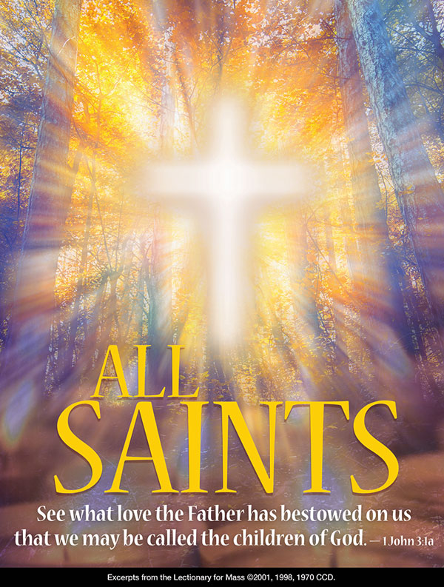


FIRST UNITED METHODIST CHURCH

301 N JEFFERSON ST

KITTANNING PA 16201

724-548-4312

E-MAIL: fumchurchkittanning@comcast.net

WEBSITE: www.firstchurchkittanning.com

PASTOR: Deb Kociban

ACCOMPANIST: Emily King

CHURCH OFFICE HOURS: Monday-Thursday 8:00-12:00 PM

KNOW JESUS, REFLECT JESUS, LEAD OTHERS TO JESUS

Prelude

Opening Prayer

Ringing of the Call to Worship Bell

Welcome and Announcements

*Opening Hymn “Majesty, Worship His Majesty” (Sing Twice) No. 176

Children’s Sermon
(Children Kindergarten through 6th grade are dismissed for Children’s Church)

*Morning Prayer of Confession
O God, we long to rest in you, to trust in your goodness, in your care for us, in your abundant life. But we don’t know how to rest and we have forgotten how to trust: We seek material goods that we don’t really need. We befriend people not always out of love. We ask questions of you like the Sadducees did of Jesus, questions that try only to prove our point, not to grow in understanding of your desires for us. Slow us down, Holy One. Attend to us, Holy One, and show us that you are our salvation and our resting place. We pray in the name of your Son, Jesus Christ. Amen.

Reading of the Saints
Arnold Crawford, Amanda Leech

Joys and Concerns/Pastoral Prayer/Lord’s Prayer
(May fill out connect cards at this time)

Morning Anthem “Lord, Help Me Be Your Servant”

Scripture Reading Luke 20:27-38 CEB N.T. p. 84

Leader: This is the Word of God, for the people of God,
People: Thanks be to God.

God’s Word for Us

Service of Word and Table

Offering/Offertory/*Doxology
*Praise God, from whom all blessings flow; praise Him all creatures here below; Praise Him above, ye heavenly host; praise Father, Son, and Holy Ghost. Amen

*Closing Hymn “Standing on The Promises” No. 374

*Altar rail is open for prayer during the closing hymn.

*Benediction

*Please stand in spirit or in body.

Ask an usher for a large print hymnal or bible or personal hearing device.

NOVEMBER SIFT LUNCHEON
Date: Thursday, November 17, 2022
Time: Noon
Menu: “Thanksgiving Dinner” Turkey with stuffing, mashed potatoes and gravy, cranberries, corn, rolls, butter and Pie.
Program: Ramps of Hope. Providing semi-permanent ramps for people who need assistance exiting and entering their homes.
Reservations due by noon, Monday, November 14, 2022

NOVEMBER MISSIONS
We have an opportunity to help share in Missions for November. We will collect money for “Embrace Grace” an established mission program at the Free Methodist Church in West Kittanning. “Embrace Grace” is for single, pregnant, young women. These women receive love and support during a difficult yet joyful time of life. The women make friends and form bonds with other expectant moms while journeying through their pregnancy. The group meets weekly and a free baby shower will be given in young mothers honor. Our church will collect monies to contribute to this event. May God bless our efforts

DECORATE THE CHURCH FOR CHRISTMAS
Everyone is invited to join us on Tuesday, November 22nd to decorate the church for Christmas. We begin around 8:30-9:00 AM and are usually finished by noon. Come when you can. Hope to see you there.

FOOD BANK
We will once again be collecting canned goods and boxed items for the Food Bank. Place your Food Bank donations on the 2 tables in front of the church for November. These items will go to our LOCAL FOOD BANK.

December Newsletter Deadline—Sunday, November 13th

Updated Membership Directories are available at all the doors and in the office.

