FIRST CHURCH WEEKLY CALENDAR
SUNDAY, September 18th
9:30 AM Sunday School
11:00 AM Worship
7:00 PM We Surrender-Church

MONDAY, September 19th
6:30 PM Finance
7:00 PM Church Council

TUESDAY, September 20th
6:00 PM Women’s Fellowship
7:00 PM New Found Freedom-CC

WEDNESDAY, September 21st

THURSDAY, September 22nd
5:30 PM Adult Choir
7:00 PM Heavenly Daughters

FRIDAY, September 23rd
7:00 PM Revitalization Team

SATURDAY, September 24th
7:00 PM We Surrender-CC

SUNDAY, September 25th
9:30 AM Sunday School
11:00 AM Worship
7:00 PM We Surrender-Church

THE FLOWERS on the altar are presented to the Glory of God in honor of my mom, Karen Scaife, given by Pam Scaife

THE FLOWERS on the organ are presented to the Glory of God in honor of Jenny Hellein & Becky McKinney’s birthdays, given by Jenny Hellein

THANK YOU to the following individuals for assisting with today’s service:
Usher Team: Epworth/Melissa Bureau
Scripture Reader:
Worship Sound System: John Yankasky
Bell Ringer: Wyatt Green
Welcome Center Greeter: Karen Scaife
Acolytes: Chelsea Beers & Evva Yanoschick

September 18, 2022
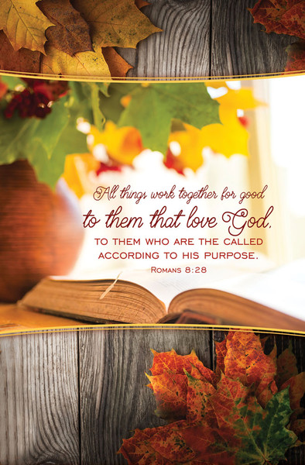


FIRST UNITED METHODIST CHURCH

301 N JEFFERSON ST

KITTANNING PA 16201

724-548-4312

E-MAIL: fumchurchkittanning@comcast.net

WEBSITE: www.firstchurchkittanning.com

PASTOR: Deb Kociban

ACCOMPANIST: Emily King

CHURCH OFFICE HOURS: Monday-Thursday 8:00-12:00 PM
Prelude

Opening Prayer

Ringing of the Call to Worship Bell

Welcome and Announcements

*Opening Hymn “Be Still, My Soul” No. 354

Children’s Sermon
(Children Kindergarten through 6th grade are dismissed for Children’s Church)

Call to Worship Psalm 100 Read Responsively

Leader: Make a joyful noise to the Lord, all the lands!

People: Serve the Lord with Gladness! Come into God’s presence with singing!

Leader: Know that the Lord who made us is God.

People: We are the Lord’s; we are the people of God, the sheep of God’s pasture.

Leader: Enter God’s gates with thanksgiving, and God’s courts with praise.

People: Give thanks and bless God’s name.

Leader: For the Lord is Good;

People: God’s steadfast love endures for ever; God’s faithfulness to all generations.

Joys and Concerns/Pastoral Prayer/Lord’s Prayer
(May fill out connect cards at this time)

Morning Anthem “Spirit Song”

Scripture Reading Luke 16:1-13 CEB N.T. p. 79
Leader: This is the Word of God, for the people of God,
People: Thanks be to God.

God’s Word for Us

Offering/Offertory/*Doxology
*Praise God, from whom all blessings flow; praise Him all creatures here below; Praise Him above, ye heavenly host; praise Father, Son, and Holy Ghost. Amen

*Closing Hymn “God Be with You till We Meet Again” No. 672

*Altar rail is open for prayer during the closing hymn.

*Benediction
*Please stand in spirit or in body.
Ask an usher for a large print hymnal or bible or personal hearing device.

OCTOBER NEWSLETTER DEADLINE
SUNDAY, SEPTEMBER 18TH

KITCHEN ITEMS
We are trying to clean out the kitchen in the church basement. We have a bunch of kitchen items that need new homes. Feel free to go down and take whatever you like. Thank you, Trustees

THANK YOU
Thank you all for the monetary and stamp donations to continue the card ministry. Caring Friends

ALTAR FLOWER DATES AVAILABLE
We have 2 dates available for altar flowers in 2022. If you would like either of these dates, please let Audrey know. We have October 30th and November 27th available.

SEPTEMBER MISSIONS
We are delighted to have two Mission opportunities for you this month:
- Rise Against Hunger will be hosted by the Leechburg UMC on Saturday, September 10th, starting at 9:00 AM. We will carpool from the church parking lot at 8:15 AM. Let me know if you will drive directly to Leechburg or will car pool. (Janet’s phone 412-390-8980). We have been asked to donate a case of bottled water and 2 dozen cookies. Would two from the congregation like to donate these items?
- HAVIN- we will donate twin sheet sets, mascara, different shades of foundations, and various eye shadows. HAVIN stands for Helping All Victims In Need. Let’s help out where there is a need!
Janet & Meaghan

