FIRST CHURCH WEEKLY CALENDAR
SUNDAY, September 11th
RALLY DAY
9:30 AM Rally Day Breakfast-CC
11:00 AM Worship
12:00 PM Art Show Committee
2:00 PM Camp 43-CC
7:00 PM We Surrender-Church

MONDAY, September 12th
7:00 PM Nurture, Outreach & Witness Team

TUESDAY, September 13th
6:00 PM Women’s Fellowship
7:00 PM New Found Freedom-CC

WEDNESDAY, September 14th

THURSDAY, September 15th
5:30 PM Adult Choir
12:00 PM SIFT Luncheon-CC
7:00 PM Heavenly Daughters

FRIDAY, September 16th

SATURDAY, September 17th
7:30 PM Movie Night-Yard
7:00 PM We Surrender-CC

SUNDAY, September 18th
9:30 AM Sunday School
11:00 AM Worship
7:00 PM We Surrender-Church

THE FLOWERS on the altar are presented to the Glory of God in loving memory of Nick Snow for his birthday, given by Jim Ternent

THANK YOU to the following individuals for assisting with today’s service:
Usher Team: Asbury/Mary Jo Lipski
Scripture Reader:
Worship Sound System: Dave Yanoschick
Bell Ringer: Logan Green
Welcome Center Greeter: Melissa Bureau
Acolytes: Carlee Beers & Ashley Yankasky

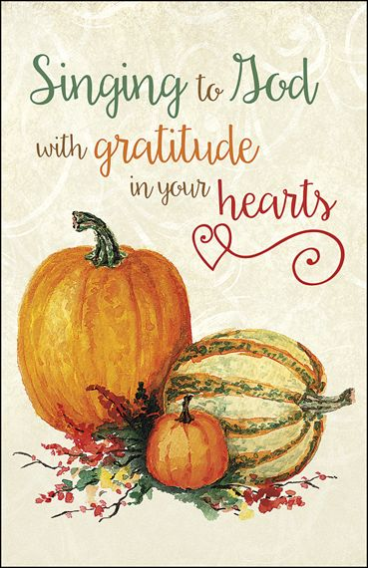
September 11, 2022


FIRST UNITED METHODIST CHURCH

301 N JEFFERSON ST

KITTANNING PA 16201

724-548-4312

E-MAIL: fumchurchkittanning@comcast.net

WEBSITE: www.firstchurchkittanning.com

PASTOR: Deb Kociban

ACCOMPANIST: Emily King

CHURCH OFFICE HOURS: Monday-Thursday 8:00-12:00 PM
Prelude

Opening Prayer

Ringing of the Call to Worship Bell

Welcome and Announcements

*Opening Hymn “Something Beautiful, Something Good” No. 394
(Sing Twice)

Bible Presentation
(Children Kindergarten through 6th grade are dismissed for Children’s Church)

Call to Worship 1 Timothy 1:15-17 N.T. p. 211 In Unison

This saying is reliable and deserves full acceptance: “Christ Jesus came into the world to save sinners” -and I’m the biggest sinner of all. But this is why I was shown mercy, so that Christ Jesus could show endless patience to me first of all. So I’m an example for those who are going to believe in him for eternal life. Now to the king of the ages, to the immortal, invisible, and only God, may honor and glory be given to him forever and always! Amen. CEB

Joys and Concerns/Pastoral Prayer/Lord’s Prayer
(May fill out connect cards at this time)

Special Music

Scripture Reading Luke 15:1-10 CEB N.T. p. 78
Leader: This is the Word of God, for the people of God,
People: Thanks be to God.

God’s Word for Us

Offering/Offertory/*Doxology
*Praise God, from whom all blessings flow; praise Him all creatures here below; Praise Him above, ye heavenly host; praise Father, Son, and Holy Ghost. Amen

*Closing Hymn “Softly and Tenderly Jesus is Calling” No. 348

*Altar rail is open for prayer during the closing hymn.

*Benediction
*Please stand in spirit or in body.
Ask an usher for a large print hymnal or bible or personal hearing device.

OCTOBER NEWSLETTER DEADLINE
SUNDAY, SEPTEMBER 18TH

SIFT (Seniors In Fellowship Together) RETURNS
Our monthly SIFT Luncheons will return beginning on Thursday, September 15th. Join us for an afternoon with a great lunch, fellowship, and an informative program.
The MENU will be ham Barbeque on Bun, Macaroni & Cheese, Chips, Pickles, and Dessert.
The PROGRAM “Experience Armstrong” presented by the Armstrong County Tourist Bureau.
Reservation are due by noon, Monday, September 12th. Please call the church office (724-548-4312) or email fumchurchkittanning@comcast.net Hope to see you on September 15th!
And mark your calendars for the Third Thursday of each month as a reminder that SIFT meets on that day.

ALTAR FLOWER DATES AVAILABLE
We have 2 dates available for altar flowers in 2022. If you would like either of these dates, please let Audrey know. We have October 30th and November 27th available.

MOVIES ON THE LAWN
We will be showing “Cheaper by the Dozen” with Steve Martin on Saturday, September 17, 2022 at 7:30 on the side yard by the Parsonage (weather permitting). Light Snacks and beverages will be provided. This is a free event.

SEPTEMBER MISSIONS
We are delighted to have two Mission opportunities for you this month:
- Rise Against Hunger will be hosted by the Leechburg UMC on Saturday, September 10th, starting at 9:00 AM. We will carpool from the church parking lot at 8:15 AM. Let me know if you will drive directly to Leechburg or will car pool. (Janet’s phone 412-390-8980). We have been asked to donate a case of bottled water and 2 dozen cookies. Would two from the congregation like to donate these items?
- HAVIN- we will donate twin sheet sets, mascara, different shades of foundations, and various eye shadows. HAVIN stands for Helping All Victims In Need. Let’s help out where there is a need!
Janet & Meaghan

